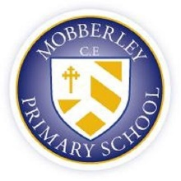

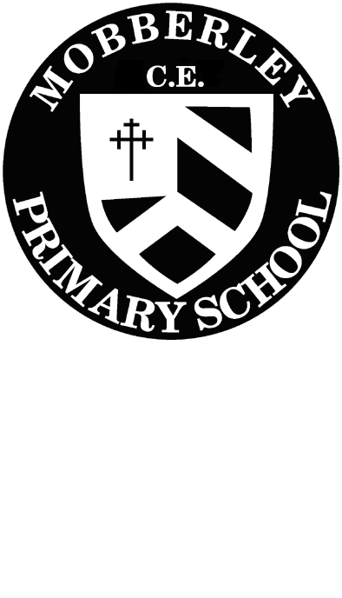 ***ASK AND IT WILL BE GIVEN TO YOU: SEEK AND YOU WILL FIND IT:***

***KNOCK AND THE DOOR WILL BE OPENED TO YOU - MATTHEW 7:7***

**English Policy**

**October 2023 – October 2024**

**Here at Mobberley, w**e believe that the development of language and literacy skills are a fundamental part of our everyday learning and teaching. Our curriculum will teach pupils to speak and write fluently so that they can communicate their ideas and emotions to others and through their reading and listening, others can communicate with them.

Children are exposed to high quality literature to inspire their own writing and to model engaging uses of the English language. Through the critique of these texts, children develop their oral comprehension skills. Imagination and originality are nurtured through exploration, discussion, and drama. Spelling, punctuation, grammar, and phonics teaching ensure that children have the skills and confidence to develop their writing style across a range of genres and in varied contexts.

**Aims**

Our ambition is to develop pupil’s abilities within an integrated programme of Speaking & Listening, Reading and Writing. Pupils will be given opportunities to practice these skills within a broad and balanced approach to the teaching of English across the curriculum, with opportunities to consolidate and reinforce taught skills.

Our ambitions:

* To deliver the statutory National Curriculum (2014) in an exciting and accessible way with high expectations of the children.
* To provide children with meaningful, engaging contexts for reading and writing.
* To read and write with confidence, fluency and understanding, orchestrating a range of independent strategies to self-edit and improve.
* To use grammar, punctuation and spelling correctly to attain high levels of Writing.
* To write with fluent, legible joined handwriting and take pride in the presentation of their work.
* To provide children with the necessary skills to become competent, confident and creative users of the English language and to prepare them for secondary school and further in life.
* To nurture children who will leave school with an interest and passion for language and literature.

**INTENT**

***Why do we teach this?  Why do we teach it in the way we do?***

Our writing curriculum aims to ensure progression of writing skills across the school, using the objectives outlined in the National Curriculum. Opportunities are provided for children to write for real purposes and audiences and to write for a sustained period each week across Key Stage 1 and 2 using key skills and processes that are essential for writing – Planning, Drafting and Writing, Evaluating and Editing, Proof Reading and Reading Aloud to Others.

Our reading curriculum aims to nurture a love for reading. We give opportunities to practise reading skills within a broad and balanced curriculum. We aim to consolidate and reinforce taught skills while exploring a variety of fiction and non-fiction texts discreetly and throughout other subjects and the school day. Reading success has a direct effect on progress in all areas of the curriculum and is crucial in developing children’s self-esteem, confidence, and motivation.

**IMPLEMENTATION**

***Teaching and Learning, Content and Sequence***

In school we ensure we follow ‘The National Curriculum (2014)’ and this has identified the objectives to be covered for each year group (Year 1, 2, 3, 4, 5 & 6). These have then been mapped into individual year groups as a Long-Term Plan to ensure coverage and progression. Medium term planning is then undertaken by class teachers and monitored by the English Lead. Teachers then plan on a weekly basis in response to the needs of the children within each class.

We teach English in daily lessons across the school, with phonics lessons being taught in EYFS and Key Stage 1, spellings being taught at the start of each English lesson in Key Stage 2. In addition, SPaG is taught through English lessons or discrete sessions in Upper Key Stage 2.  A clear lesson objective and success criteria are a feature of all English lessons. Working walls may support learning in the classrooms. Evaluative marking is used and Assessment informs planning.

English is taught every day and consists of the elements below;

**Reading**

Our reading curriculum aims to nurture a love for reading. We give opportunities to practise reading skills within a broad and balanced curriculum. We aim to consolidate and reinforce taught skills while exploring a variety of fiction and non-fiction texts discreetly and throughout other subjects and the school day. Reading success has a direct effect on progress in all areas of the curriculum and is crucial in developing children’s self-esteem, confidence, and motivation.

Children in Reception have 1:1 reading sessions and Year 1 and Year 2 have small group reading sessions in ability groups, building up to some whole class reading as they move through Year 2. In Reception and KS1 the children access a variety of fiction and non-fiction texts as well as those purely aimed at reinforcing their phonics using decodable books matched to their phonics stage and sounds. In Year 3 the children continue to have a selection of banded books and are gradually introduced to chapter books to widen their reading experience. In Years 4 to Year 6, children continue to have banded books, tailored to their appropriate level, alongside access to classroom reading areas to choose books by their interests. Class teachers carefully monitor the children’s reading diet and support them in accessing books to engage and develop their reading. Class teachers keep careful records of children’s reading through a reading record and a class record in KS2.

In Reception and KS1, children have daily rhyme and story time. Children will read the class ‘favourite five’ books daily or weekly to expand children’s reading diet each day.

In Years 2 to 6. children have a daily whole class shared reading session following a whole class text where a high-quality text is shared with the whole class. Texts are progressive across school and can be a mixture of narratives, non-fiction, and poems. Whole class shared reading sessions are progressive and differentiated to meet the needs of all children in the class, however, allows children to develop understanding and comprehension questions as a whole class. Whole class reading sessions allow children to practise their word reading, comprehension skills including reading for pleasure and developing positive attitudes towards reading, comprehension to improve fluency, accuracy and understanding of texts and comprehension to practise discussion, retrieval, and analysis skills. Whole class shared reading allows children to enjoy reading, practise their reading and comprehension skills. Children have examples modelled by the teacher and then practise their skills independently to deepen their understanding of key texts and comprehension test techniques.

In KS2, children who require further support, read individually with an adult and/or as part of a small group, reinforcing their knowledge of blending and segmenting. Children are also given the opportunity to read for pleasure and are encouraged to use reading areas in classrooms, quick read Fridays and bring books from home, to enjoy silently by themselves.

Year 2 to Year 6 have book club once per week in their class so they can be introduced to new books, books in their reading corner or within their coloured book bands. This is also opportunity for teachers to share their recommended books with the class.

Classes have story times at least 4 times per week.

Standardised tests are used to assess children in their reading comprehension.

**Spellings**

In KS2 and for children who are ready in Year 2, we follow the Mobberley Spelling Programme which allows children to revise the sounds taught in phonics and apply these to spellings and spelling patterns. Spellings are taught each day at the beginning of English lessons, following five different activities for the same spelling sound or rule. At the start of the week, teachers introduce the sound or spelling rule of the week, children highlight the sound or rule within the words given. This leads into a partner test, where children test each other on six spellings of the week. Children then identify the spellings they need to practise for the rest of the week. Following on from this, with the spellings they need to practise, children will analyse the sounds, segmenting the words into each phoneme or grapheme, using their phonics knowledge, and applying this to the spellings. Children will then sort the words into spelling groups with the same sound or rule. Finally, an adult will test children on the spellings of the week. Children receive two marks for a spelling if the whole word is correct and one mark if they wrote the correct spelling for the sound or rule.

Vocabulary is taught explicitly in KS2. This varies from topic and science related words used more in writing. We teach a word of the week to extend children’s vocabulary. Children are encouraged to use the words they have learned in their writing too.

**Handwriting**

At Mobberley, we follow the ‘Mobberley Style’ handwriting, which is taught from Reception to Year 6. In Reception and Year 1, children practise forming letters of sounds taught in their phonics lessons, using the correct formation of the Mobberley Style.

In Years 2 to 6, following the Mobberley Spelling Programme, we incorporate handwriting into the five activities. Children in Years 2 to 4 practise their handwriting with individual spellings. Children in Years 5 and 6 practise their handwriting with the spelling in a sentence, dictated by an adult.

In Years 3 and 4, once children show an expected level with their handwriting, they can earn a pen licence certificate. Once they gain their certificate, children will be able to use pen to write up final pieces of work and in handwriting practice.  In Years 1 and 2, children with an outstanding level of handwriting, will gain a handwriting certificate and a special pencil to write with to celebrate their achievements. All children in Year 5 and 6 are encouraged to write in pen in all subjects. Handwriting will be assessed by teachers and the English subject lead before pen licences and certificates are awarded.

**Writing**

Our writing curriculum aims to ensure progression of writing skills across the school, using the objectives outlined in the National Curriculum. Opportunities are provided for children to write for real purposes and audiences and to write for a sustained period of time each week across Key Stage 1 and 2 using key skills and processes that are essential for writing – Planning, Drafting and Writing, Evaluating and Editing, Proof Reading. Writing lessons are linked to a class text, poetry, film clips or a wider curriculum topic. Themes are chosen challenge and inspire the children’s writing. Teachers plan writing opportunities inspired by texts and will regularly use examples from the text to model writing. English skills are continually assessed by teachers observing children in lessons and providing in the moment feedback. Termly, teachers meet to moderate writing standards across their year groups and look at the next steps for their classes.

**Celebration of poetry:**

To celebrate poetry at Mobberley CE Primary School, each month every class will focus on a poem. Children will study and perform the poem over the month. This allows children to experience a wide range of poetry each year. This is an additional opportunity children will have alongside the poetry they study within English lessons.

**Our English’ lesson format:**

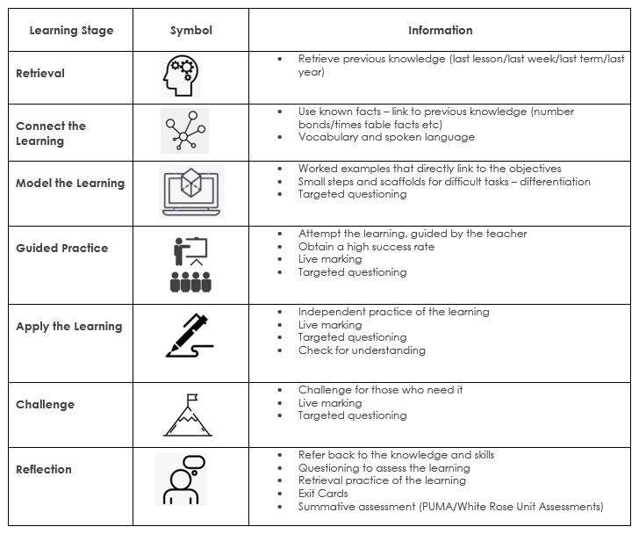

* Use known knowledge and apply this into writing, reading comprehension and SPAG activities.
* Vocabulary and spoken language.
* Refer back to the knowledge and skills.
* Questioning to assess learning
* Retrieval practice of the learning.
* . Summative assessment (PIRA/GAPS)
* Hot writes – end of unit pieces of writing.
* Retrieve previous knowledge from last lesson, last week, last term, last year.
* Cold writes at the start of units to assess prior knowledge.

**English in EYFS:**

**EYFS**

In EYFS at Mobberley, the three prime areas are strengthened by literacy. Children will be taught to link sounds and letters and to begin to read and write. Children will be given access to a wide range of reading materials to ignite their interest. The prime area Communication and Language, will be particularly strengthened by children being given many opportunities to experience a rich language environment; to develop their confidence and skills in expressing themselves; to speak and listen in a range of situations.

Our English curriculum in EYFS is planned through a series of themes that reflect and respond to the children’s interests, offering experiences in all areas of the curriculum and which carry equal importance to provide a broad and balanced curriculum with opportunities for play and child- initiated activities.

The EYFS class provides the following areas to help children with their literacy learning: • Small world area for retelling stories and small world play/exploration

• Role play area

• Book corner with a range of fiction and non-fiction books

• Writing table with a range of writing resources

• Finger Gym area to support the children’s fine motor skills.

• Phonics activity table

Within the Early Years at Mobberley, the following characteristics of learning underpin literacy teaching and learning in the EYFS and form part of the skills and attributes that children need to acquire by the end of their literacy learning journey in the Foundation Stage.

• Playing and exploring - Finding out and exploring; Playing with what they know; Being willing to ‘have a go’

• Active learning - Being involved and concentrating; Keeping trying; Enjoying achieving what they set out to do

• Creating and thinking critically - Having their own ideas; Making links; Choosing ways to do things

Language and Literacy Supporting the Reception Child

• Early in the first half term at school, children will begin to bring home sound cards so that parents/carers can support their child with the sounds he/she has learnt at school. This will be explained in detail at the Reading/ Writing workshop for parents.

• The first books that children bring home to share with parents/carers will be link to the sounds they have previously learnt and will have simple repetitive text and rhymes. They will only get a reading book when they are ready to start their reading journey.

• Children also bring home a library book for parents to share and read with their child.

• Each child may also take home a range of reading games or activities that involve matching sounds and pictures; making, reading and writing simple words that can be practiced at home

Assessment of literacy in the Early years is through observations and activities to assess each child’s understanding. As part of daily practice, we observe and assess children’s development and learning to inform our literacy plans. We record our observations using the online learning journey ‘Evidence Me’ and these could be photographs of the children’s literacy work or activity, videos or direct speech and adult-lead directed writing goes in our English books.

**IMPACT**

Our English curriculum is of a high quality and ensures there is clear progression. In order to ensure we measure impact, we gather a variety of data and feedback to check whether learning has occurred. The information gathered through these methods directly impacts the future planning of teaching and learning opportunities, ensuring that we are responsive to the needs of our learners.

***Formative assessment*** through daily retrieval practice we can check for children’s retention of previously taught concepts.*Formative assessment* takes place on a daily basis and teachers adjust planning accordingly to meet the needs of their class.  Teachers use formative assessment to evaluate the learning during a lesson. They may ask questions to check understanding or scrutinise independent work in order to identify gaps in basic skills or share ideas for vocabulary or spellings. Such assessment allows teachers the flexibility to intervene in a lesson to remind, redirect or reteach pupils as required.

Cold writes, daily retrieval practice, applying basic skills in every day writing, effective feedback to address basic skills, planning is adaptive to meet the needs of the class.

***Summative assessments*** include whole school moderations, PIRA tests, weekly spelling tests, termly spelling tests, GAPS tests and moderation across school and across the local authority. Results from these assessments feed into teaching and focus groups. Children’s progress and attainment is discussed with senior leaders in pupil progress meetings.

**OUR ENGLISH LEARNING ENVIRONMENT**

Our curriculum is supported by a rich learning environment. Working walls support children’s learning in every classroom for English.

* English (writing and shared reading) working walls are in constant use throughout individual lessons and across weeks focusing on a particular domain.
* Key vocabulary is displayed.
* Worked examples are modelled and displayed for reference (sometimes including pictorial and concrete representations).
* Displays around school show writing progression and enjoyment of poetry.

**Special Educational Needs & Disabilities (SEND)**

Daily English lessons including writing, spellings, phonics and reading are inclusive to pupils with special educational needs and disabilities. Where required, children’s support plans incorporate suitable objectives from the National Curriculum for English and teachers keep these in mind when planning work. These targets may be worked upon within the lesson as well as on a 1:1 basis outside the English lesson. Writing, reading, handwriting, spelling and phonics focused intervention in school helps children with gaps in their learning and understanding.

These are delivered by class teachers and trained support staff and overseen by the SENCO and/or the class teacher. Within the daily English lessons including writing, spellings, phonics and reading, teachers have a responsibility to not only provide differentiated activities to support children with SEND but also activities that provide sufficient challenge for children who are high achievers. It is the teachers’ responsibility to ensure that all children are challenged at a level appropriate to their ability

**ROLES AND RESPONSIBILITIES**

It is the role of the Subject Leader to ensure that, along with SLT, the subject is monitored using a range of processes to inform the development of English teaching and learning. Outcomes are shared with colleagues and appropriate actions are implemented. It is the role of the Subject Leader to identify and support the training needs of colleagues.

The Subject Leader engages with professional development and learning and imparts their interest in English to the school community. It is the role of the Subject Leader to ensure that pupil voice is valued and responded to and there is an understanding of the importance and value of English amongst the staff and children.

It is the school’s role to provide effective support for the Subject Leader’s development of English.

It is the responsibility of all staff to inform the Subject Leader of resources that need replenishing or are required to enhance the teaching and learning of English.

**REVIEW**

This policy is monitored through:

* Regular scrutiny of children’s work
* Regular monitoring and evaluation of planning
* Evaluation and analysis of assessment data
* Lesson observations to monitor the quality of teaching and implementation of planning
* Pupil interviews and questionnaires
* Teacher feedback

The English policy will be reflected in our practise. The policy will be reviewed October 2024.