08.01.2025 Factor Pairs
A factor pair is a pair of numbers which when multiplied together make a product. Both numbers are factors of the product.
For example, 2 × 5 = 10 so 2 and 5 are factors of 10.
2 and 5 are also referred to as a ‘factor pair’ of 10.

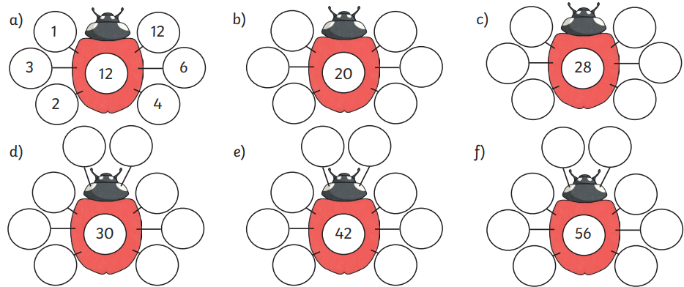
- Complete the factor pairs. The first one has been done for you.

- Complete each rainbow by filling in the missing numbers to create each factor pair. The first one has been done for you.




