 **+P16/01/2023**

**16/01/2023**

**Our School Mission is inspired by Matthew 7:7**

**“Ask and it will be given to you; seek and you will find; knock, and the door will be opened to you.”**

**31/03/2025**

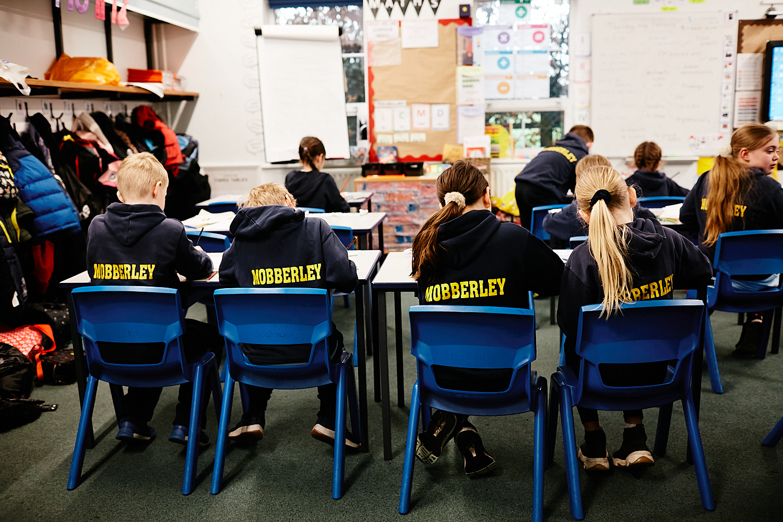 

*“Let us celebrate with a feast! For this son of mine was dead, but now he is alive; he was lost, but now he has been found.”*

*Luke 15: 1-3*

**THOUGHT FOR THE WEEK**

“God of surprises, help me to see you in all of life’s unexpected happenings so that I can see that you never leave any of us alone or unsupported.”

Dear Parent / Carer,

As we enter our last week in school before the Easter break, we are concluding our Lenten reflections. Worship this week continues to focus on the Christian Value of Respect, particularly relating this to supporting our recent charitable fundraising. Tomorrow, Fr Ian and the Ethos team will lead us in our Palm Service in St Wilfrid’s Church. Parents are always welcome to join us for this (although space is quite tight.) Parents of Reception class who may not have experienced a Church service before are particularly welcome. On Friday we will also be holding our Stations of the Cross service in the school hall led by our Ethos team.

Parent meetings will be held over the next few evenings. Thank you for your patience with the new School Spider system. I know it will be a big improvement for us in terms of communications going forward. Apologies to those parents who have had difficulty linking their emails. We will endeavor to get all parents connected in the coming days.

Year 5 are looking forward to their Anglo Saxon/Viking trip this Wednesday. Good weather is predicted this week so it should be lovely.

Well done to our Y6 footballers who battled bravely at St Vincent’s last Wednesday. Unfortunately, they lost 3-2 but there was very little between the teams. Further Y6 matches are being planned for forthcoming weeks – The UK Football Academy (morning training company) will be taking a lead on these.

Can I wish all our families a peaceful Easter; I am very mindful of those families who have been recently bereaved or have anniversaries at this time. Our thoughts and prayers are with you.

Best wishes for the week ahead.

Damien Stenson

Headteacher

**WINNING**

**HOUSE**

Griffin - 283

Wilfrid - 279

Mallory - 267

Green - 264

Congratulations to Griffin our winners for the week ending 28/03/2025

**ATTENDANCE**

Reception – 97.60%

Year 1 – 96.67%

**Year 2 99.29%**

**Year 3 – 99.68%**

Year 4 – 98.93%  
Year 5 – 96.90%

Year 6 – 97.14%

Congratulations to **Year**

**2** our class winners in Key Stage One and, **Year**

**3** our Key Stage Two winners.



**VIP  
Values In Practice**

Our VIP’s this week for demonstrating our Christian Values are:

Reception Henry W (Perseverance & Respect)

Year 1 Emi D (Perseverance)

Year 2 Spencer R (Perseverance)

Year 3 Isaac B (Perseverance)

Year 4 Frankie C (Friendship)

Year 5 Leah N (Respect)

Year 6 Ted L (Courage and Friendship)

**GOOD TO BE GREEN**

Reception Otto L

Year 1 Freddie R

Year 2 Edie L

Year 3 Alexander M

Year 4 Louisa T

Year 5 Lea H

Year 6 Beatrice E-J

**GOLDEN**

**CERTIFICATE**

Reception Amelia McK

Year 1 Arlo C

Year 2 Joseph D

Year 3 Olivia L

Year 4 Olivia M

Year 5 Luna-Blue McD

Year 6 Harry S

**Notices!**

Girls who have football on Thursday lunchtime **MUST** get changed into sports clothing and have their own shin pads, football socks and boots.

They will not be allowed to go out if they do not have a FULL change of clothes – including underwear, bring a towel too, when the field is wet and muddy.

Footballers also attending squad training please bring a towel and a bag for muddy kit.

Social Media Consent Forms

If you haven’t already returned this consent form please can you do so as soon as possible.

**After School Arrangements**

If your child is participating in an after - school club, a sporting event or on a trip, please notify Mrs Norbury if you **DO NOT** need them to got to MOPS that day/week.

Thank you

**Upcoming Schedule of Events**

**W/C 31/03/2025**

**31/03/2025 Parents Evening R-Y6**

**31/03/2025 Year 5/6 Netball**

**01/04/2025 Palm service in church 9.30am**

**01/04/2025 Parents Evening R-Y5**

**01/04/2025 Girls Football Match @Bexton 3.30pm**

**01/04/2025 Forest School for Year 5**

**01/04/2025 Year 3/4 Football Training 8.00am**

**01/04/2025 Drumming Lessons**

**01/04/2025 WFA After School Football**

**02/04/2025 Year 5 Anglo Saxon 7 Viking Trip**

**02/04/2025 Parents Evening Year 3 and Year 6**

**02/04/2025 Year 5/6 Football Training 8.00am**

**02/04/2025 Music4Life Piano/Keyboard**

**03/04/2025 Junior Girls Lunchtime Football**

**03/04/2025 Multi Sports Junior’s Years 3-6**

**04/04/2025 Music for Life guitar lessons**

**04/04/2025 Reception class Library Friday**

**04/04/2025 Stations of The Cross Assembly 1pm**

**04/04/2025 School Breaks up for Easter Holidays**

**W/C 21/04/2025**

**23/04/2025 School re-opens**

**23/04/2025 Year 5/6 Football Training 8.00am**

**23/04/2025 Music 4 Life Piano/Keyboard Lessons**

**24/04/2025 Junior Girls Lunchtime Football**

**24/03/2025 Multi Sports Session (Year Group TBC)**

**25/03/2025 Art Club 3.30-4.40pm in Year 3 25/03/2025 Music for Life guitar lessons**

**Acts of Kindness**

Thank you to the following children who have made such a positive difference to people in our school by being kind to others.

Riva P

Evelyn C

Isla C

Holly W-H

Felicity N

Alexander P

Alice T

Archie M

Poppy R

Ted L

Bonnie H

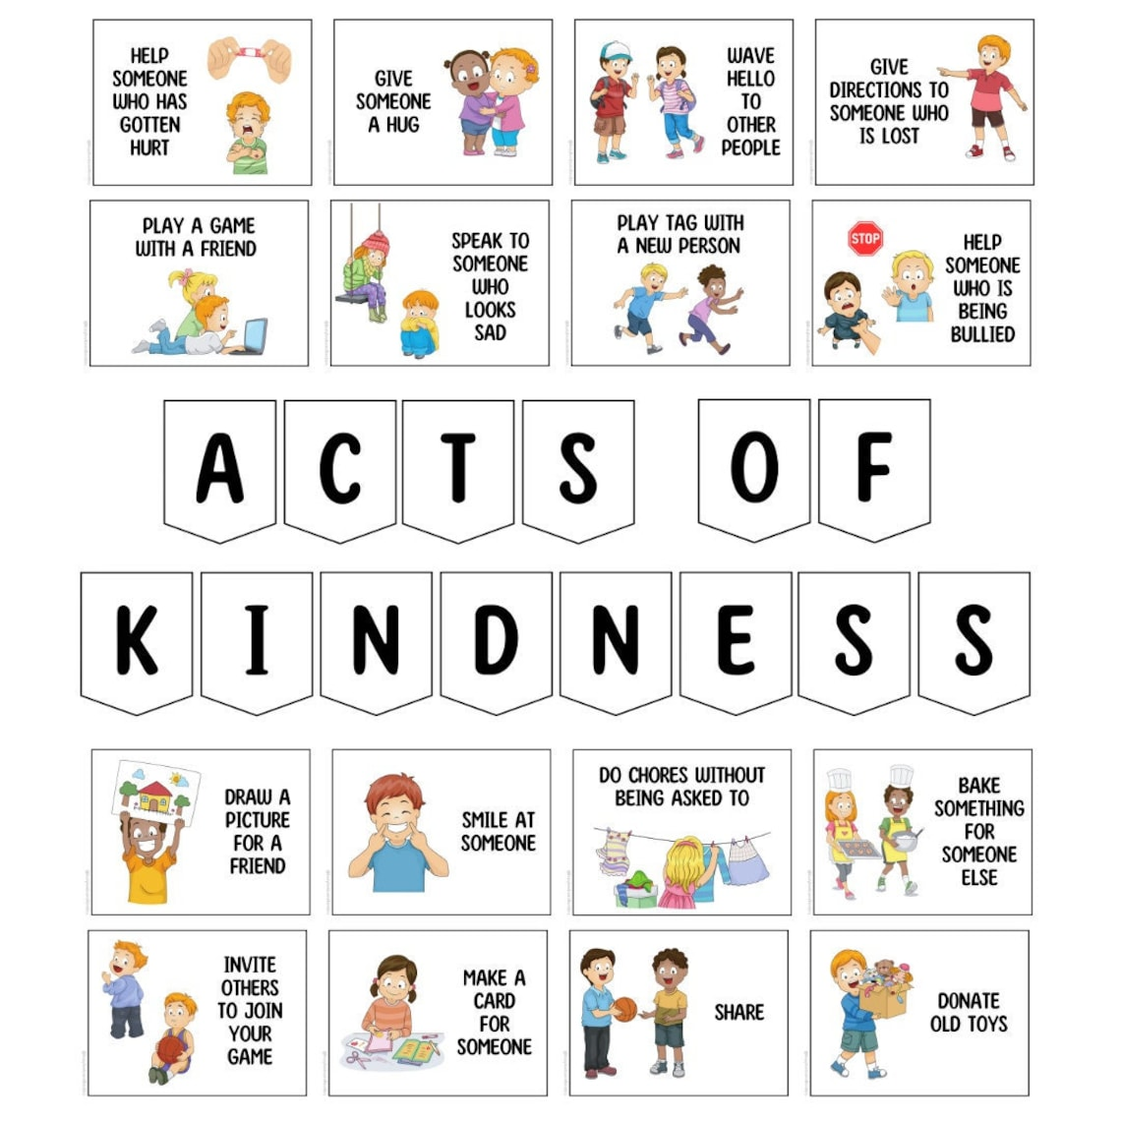

**Mathematician of The Week**

Reception Arthur H

Year 1 Phyllis S

Year 2 Caleb C

Year 3 Hattie M

Year 4 Paige H

Year 5 Thomas P

Year 6 Millie A

