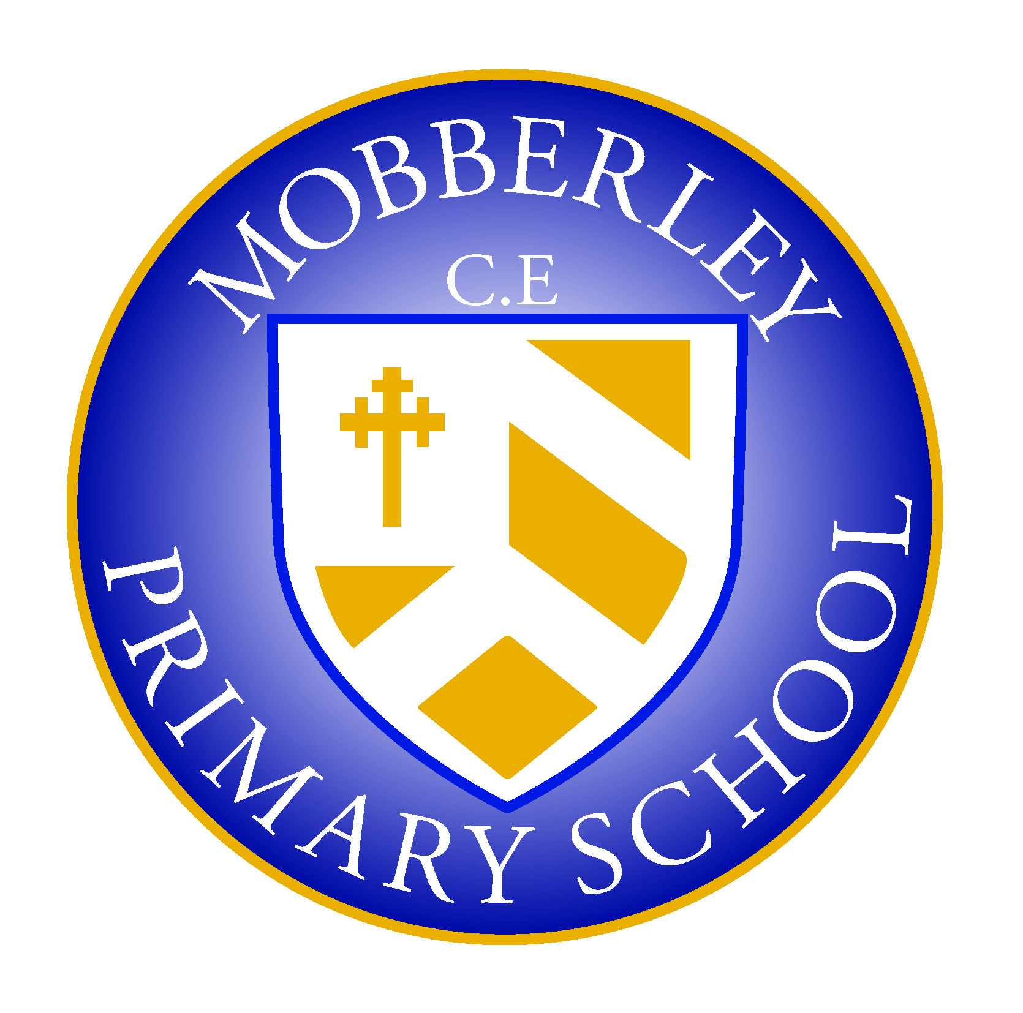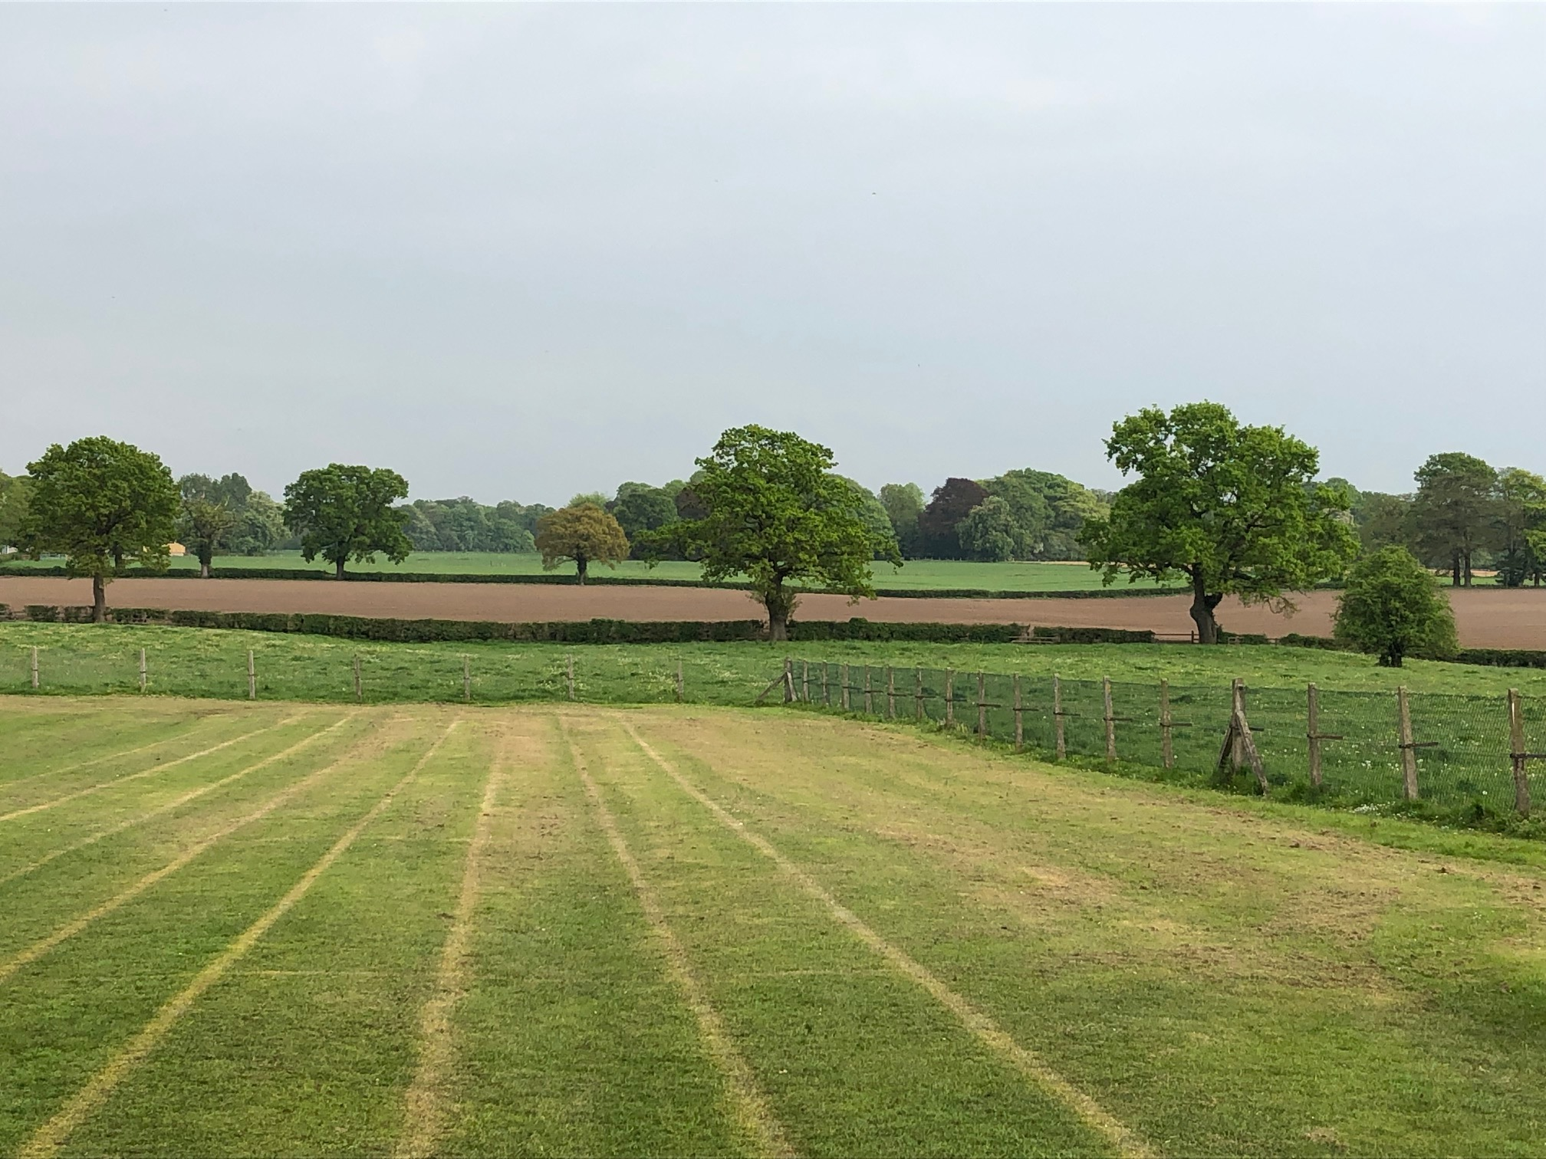

MOBBERLEY CHURCH OF ENGLAND PRIMARY SCHOOL

Church Lane, Mobberley, Cheshire, WA16 7RA

Headteacher: Mr D Stenson B.Ed NPQH

T: 01625 800 920 • E: [admin@mobberley.cheshire.sch.uk](mailto:admin@mobberley.cheshire.sch.uk) • W: www.mobberley.cheshire.sch.uk

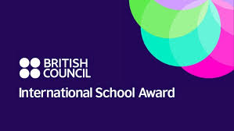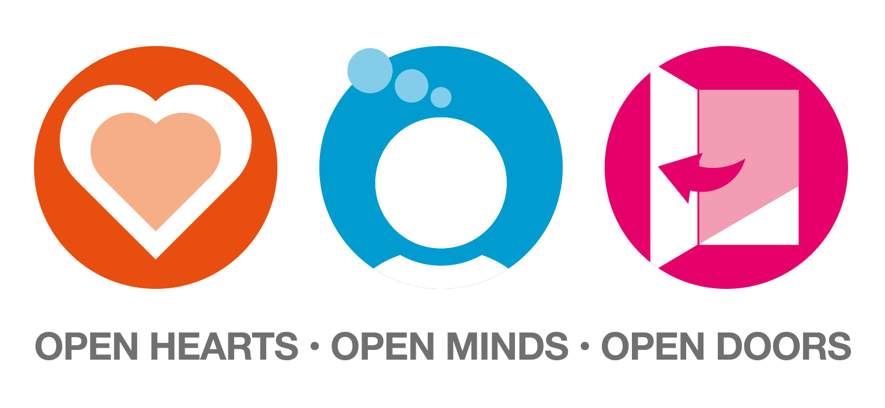

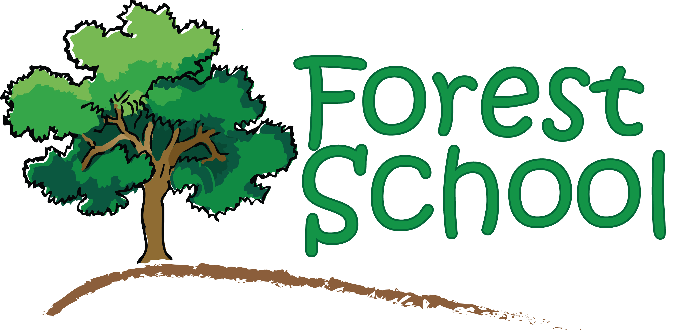

**Free School Meals & Pupil Premium**

There are two free school meal schemes:

* Universal Infant Free School Meals
* Income Related Free School Meals

In September 2014, Central Government introduced an initiative to provide free school meals to all Infant (Reception, Year 1 and Year 2) children regardless of their parents’ income levels. This is called Universal Infant Free School Meals, and you may see the abbreviation UIFSM’s used.

Even if your child qualifies for UIFSM, as an Infant pupil, if you meet any of the assessment criteria for Income Related Free School Meals it is **vital** that you apply and register with the Free School Meals Team at Cheshire East Council. This is important because, for children in receipt of Income Related Free School Meals, the school receives an additional sum of money called Pupil Premium into the School’s budget. This funding is used to support eligible pupils with their education e.g. support in curriculum studies, funding of after school clubs, funding for school trips etc.

Please be assured that the staff at Mobberley C of E Primary School do not receive information about your individual circumstances from Cheshire East. We are simply notified of eligibility start and end dates. Your child / children cannot be identified in any way to other pupils. We strongly recommend that if you consider you might be eligible for Income Related Free School Meals you take up your entitlement. If you have any queries regarding this information please speak to myself.

You can claim free school meals for each child who attends school in Cheshire East if you receive one of these benefits:

* Universal Credit with no earned income or with net monthly earnings less than £616.67
* Income Support.
* Income based Jobseeker's Allowance.
* Income related Employment Support Allowance.
* Support under Part VI of the Immigration and Asylum Act 1999.
* The guaranteed element of State Pension Credit.
* Child Tax Credit - as long as you have a yearly household income of less than £16,190 (as assessed by HM Revenue and Customs) and do not get Working Tax Credit.
* Working Tax Credit run-on (paid for 4 weeks after you stop qualifying for Working Tax Credit).

Parents and carers can apply online for Free School Meals (FSM) and get an immediate decision for their entitlement. Information about free school meals and the link for making applications can be found at <https://www.cheshireeast.gov.uk/schools/free_school_meals.aspx> . Please note that you must click the box which is entitles ‘Apply for Free School Meals’ and NOT the link at the bottom which reads ‘Free School Meals’.

Applications can also be made by telephone on 0300 123 5012. For parents applying for places in Reception, applications can be made through the same portal as you apply for a school place.

You will need your child’s date of birth and national insurance number in order to make a claim.

FSM will begin as soon as the decision is made, or for Reception children, as soon as they start school. Cheshire East is unable to backdate claims for Free School Meals to cover unpaid dinner money, or to refund any dinner money paid prior to the date of a successful application.

Eligibility for free school meals is reviewed periodically and providing you are still eligible your claim will be renewed automatically. It may be necessary for parents/carers to re-apply; this will be prompted by Cheshire East if required. It is the responsibility of the claimant and not that of the school to ensure that we have the correct information.

You must notify the Cheshire East Customer Contact Centre:

• If you stop receiving any of the stated benefits or commence receiving Working Tax Credit.

• Your child changes school or leaves school.

• You change your address.

If you do not notify Cheshire Ease of any changes in your circumstances then you may be invoiced for the cost of any free school meals taken that you were not entitled to.

Local Authorities do not set the qualifying criteria for free school meals and Cheshire East is unable to waive them. Any change to the criteria is a matter for central, not local government, so your Member of Parliament is the appropriate person to contact about this issue.

Yours sincerely,

Damien Stenson,  
Headteacher