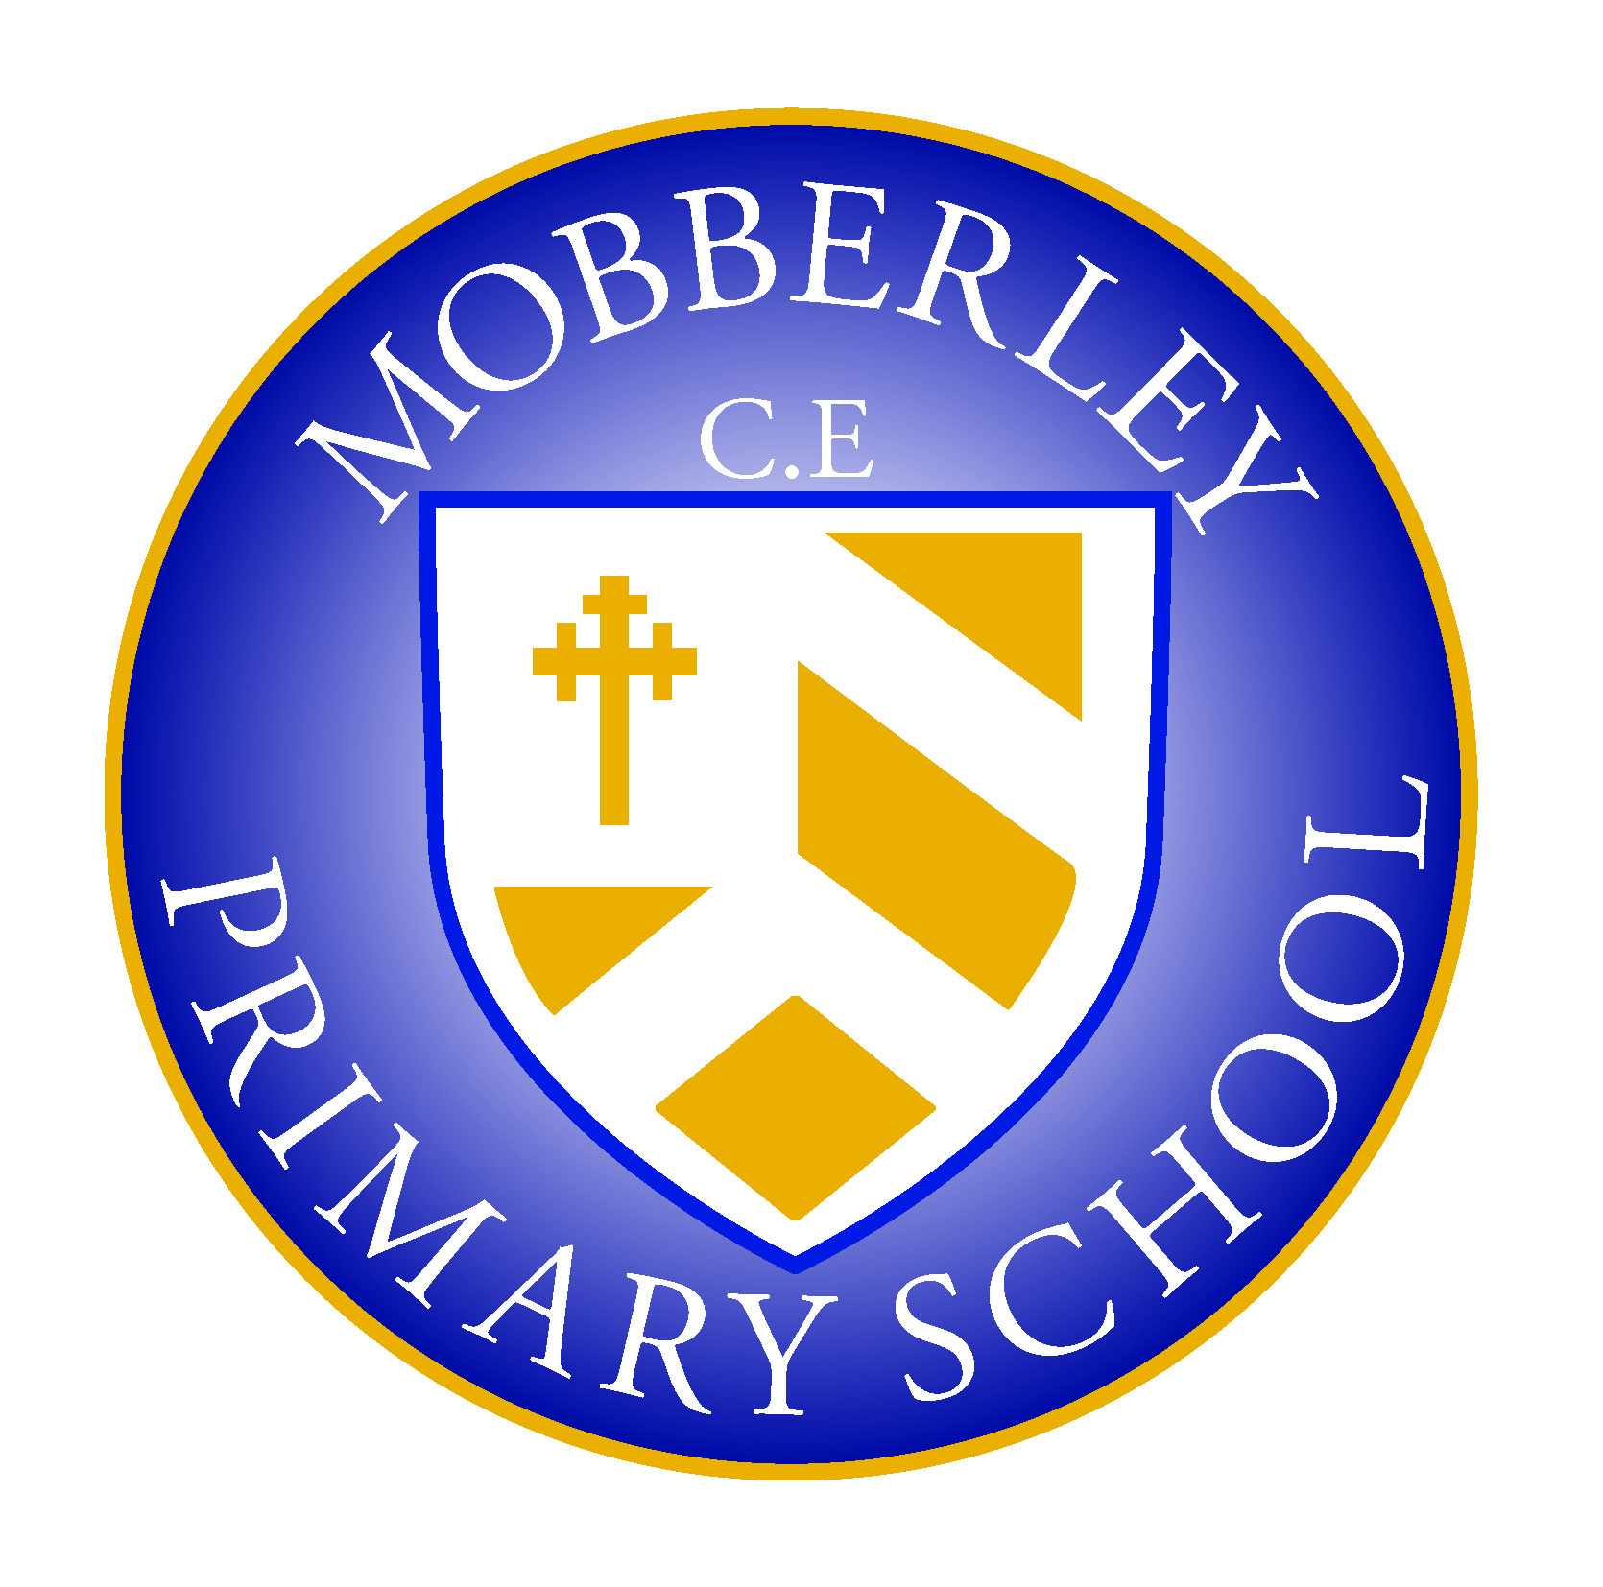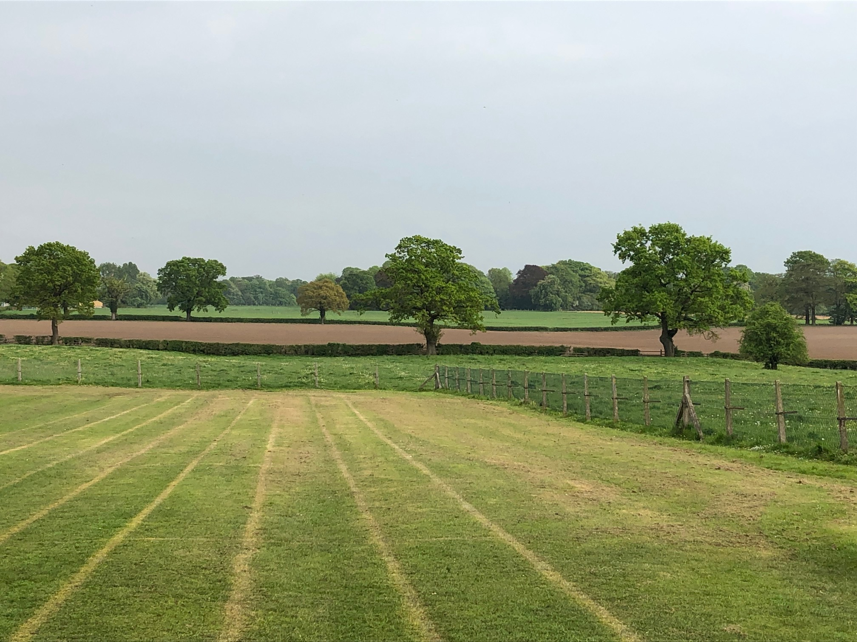

MOBBERLEY CHURCH OF ENGLAND PRIMARY SCHOOL

Church Lane, Mobberley, Cheshire, WA16 7RA

Headteacher: Mr D Stenson B.Ed NPQH

T: 01625 800 920 • E: [admin@mobberley.cheshire.sch.uk](mailto:admin@mobberley.cheshire.sch.uk) • W: www.mobberley.cheshire.sch.uk

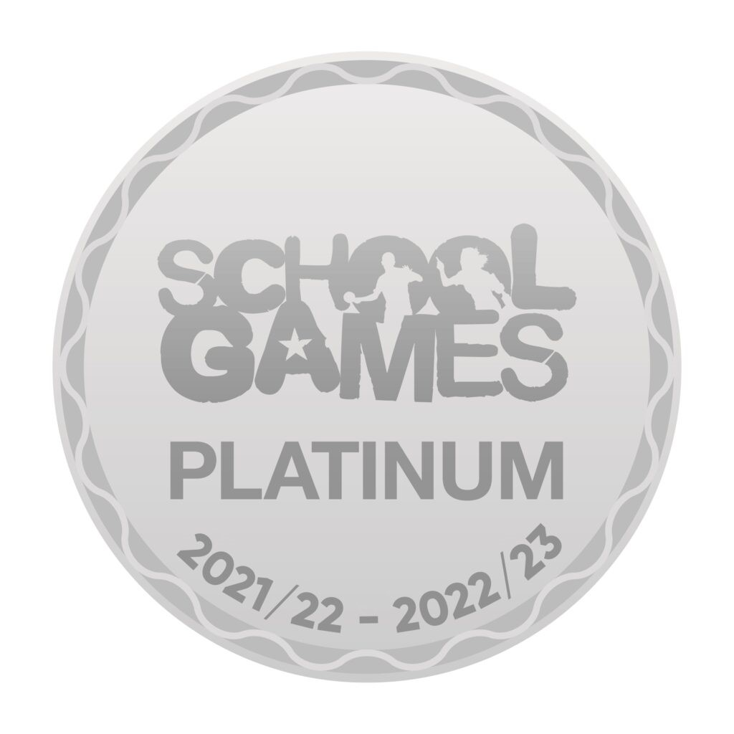



**SCHOOL CORRESPONDENCE**

Dear Parents / Carers,

At Mobberley CofE Primary School we try to adopt a paperless approach to contacting parents and carers for some of our general communication. With the growth in e-mail, smartphones and general home computer use, for many, this is the preferred method of communication. There are benefits for all parents and carers adopting this method of communication.

* Communicating with home directly via email is far more reliable and faster than relying on students to deliver letters and notices home. It is not unusual for a parent to find letters that are weeks old at the bottom of a school bag!
* More frequency of information, keeping parents / carers better informed.

The following communication is not emailed to parents / carers:

* The weekly newsletter published on Monday lunchtimes - the latest 2 editions are always available to read online via the School Website (<http://www.mobberley.cheshire.sch.uk/parents/newsletter/>)  
  This is the most up to date source of information about what is going on in school and we suggest that parents save the link to their favourites in their web browser.
* Letters requiring a written response and / or a remittance from parents to be returned to school (e.g. letters for class trips or sporting fixtures). We do, however, sometimes ask for email permission where a prompt response is required.

It is vital that we have up to date e-mail addresses if we are to communicate with you effectively. If at any time you do not want us to contact you via email we will comply with your request. These details will be stored in a secure location and we do not pass on your contact details to any other parties. Our systems are Firewall and password protected.

We still continue with paper-based communication for those parents who express a preference for this but the benefits as outlined above are undeniable, and we hope that you will join us in our efforts.

We are starting to move ALL our school communication to School Spider, including emails, texts, Breakfast & After School bookings, trips and dinner bills. Once your child has started at school and we have all of their data records on our systems, you need to download the app via the Apple Store or Google Play Store by searching School Spider Parents. Please select our school name and “Create account” using the email that you have nominated for school to use. You can find a more detailed user guide here https://www.schoolspider.co.uk/wp-content/uploads/2024/04/Parent-App-Guide-.pdf

School Spider can send communications to both parents. Please ensure that you supply us with ALL relevant email addresses. We have no plans to stop using the school admin email for communications until we are certain that all parents are accessing the app successfully so please do not worry if you face any problems.

Please complete the enclosed correspondence slip and return it to school as soon as possible. Going forward, it is essential that you remember to inform us of any changes to your email address or indeed any other data, particularly mobile telephone numbers, addresses, and medical updates concerning your child.

Yours sincerely,

Damien Stenson  
Headteacher