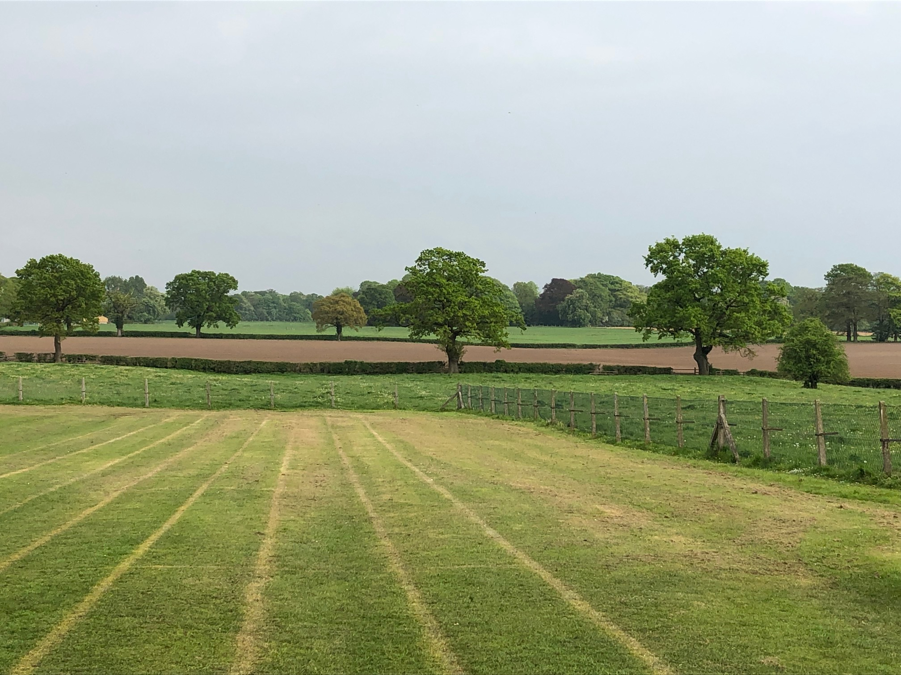

MOBBERLEY CHURCH OF ENGLAND PRIMARY SCHOOL

Church Lane, Mobberley, Cheshire, WA16 7RA

Headteacher: Mr D Stenson B.Ed NPQH

T: 01625 800 920 • E: [admin@mobberley.cheshire.sch.uk](mailto:admin@mobberley.cheshire.sch.uk) • W: www.mobberley.cheshire.sch.uk





Dear Parents & Carers,

**Re: Social Media**

Mobberley School is expanding our online presence with our use of social media. We want to celebrate and share the brilliant work that goes on here on a daily basis with our parental body. There is so much to celebrate and show you! I hope you will enjoy seeing regular pictures of your children enjoying their various activities, trips and sporting events. It is also a good way to keep you up to date with school topics and celebrating achievements.

Obviously, with any use of social media, we take our safeguarding responsibilities extremely seriously and, therefore, we will ensure that no child is identified by name in any online photos. We are, also, very mindful of those parents who may not wish for their children to take part in social media posts. We respect this and these children will not be in photographs / videos that appear on social media platforms associated with the school. These children will either not be part of photographs or will have their faces obscured to avoid identification, e.g. in group photos. Please complete the attached form to state whether you do or do not consent to your child’s photo being on social media.

We are very conscious of being ‘online role-models’ to our children and in our recent focus on National Internet Safety Week, we promoted appropriate content, usage, comments, screen time, etc. to keep the children informed about staying safe online.

Our current ‘live’ accounts are:

* X (Twitter): @MobberleySchool
* Instagram: mobberleyprimaryschool
* Facebook: Mobberley CE Primary School

Please follow us to see updates and you are welcome to share our activities. One of our aims is to share our wonderful school experiences with prospective parents so if you can help us with the promotion of the school in any way, this would be a great help.

Yours sincerely,  
Damien Stenson