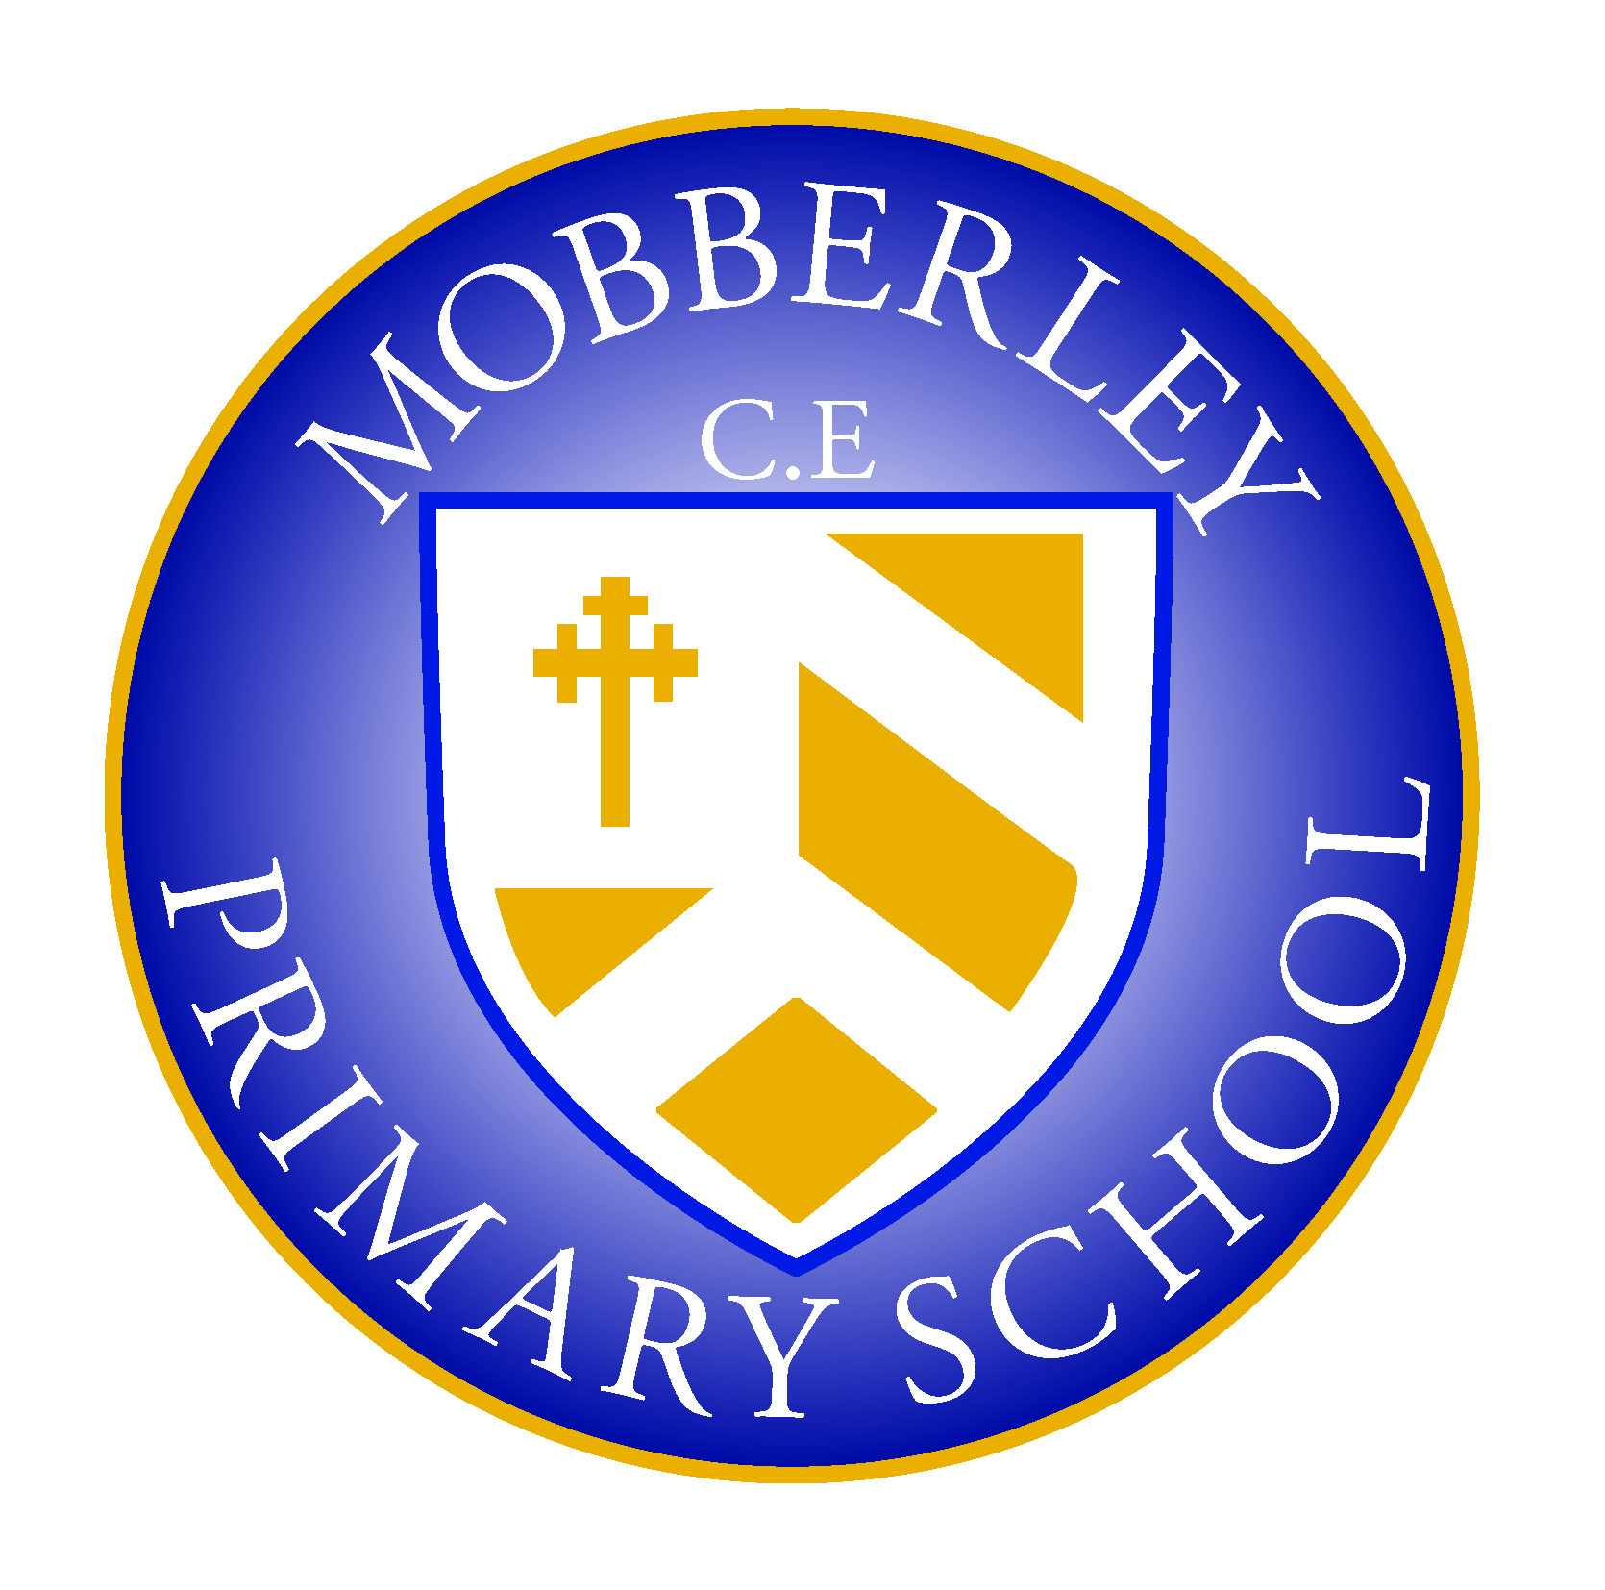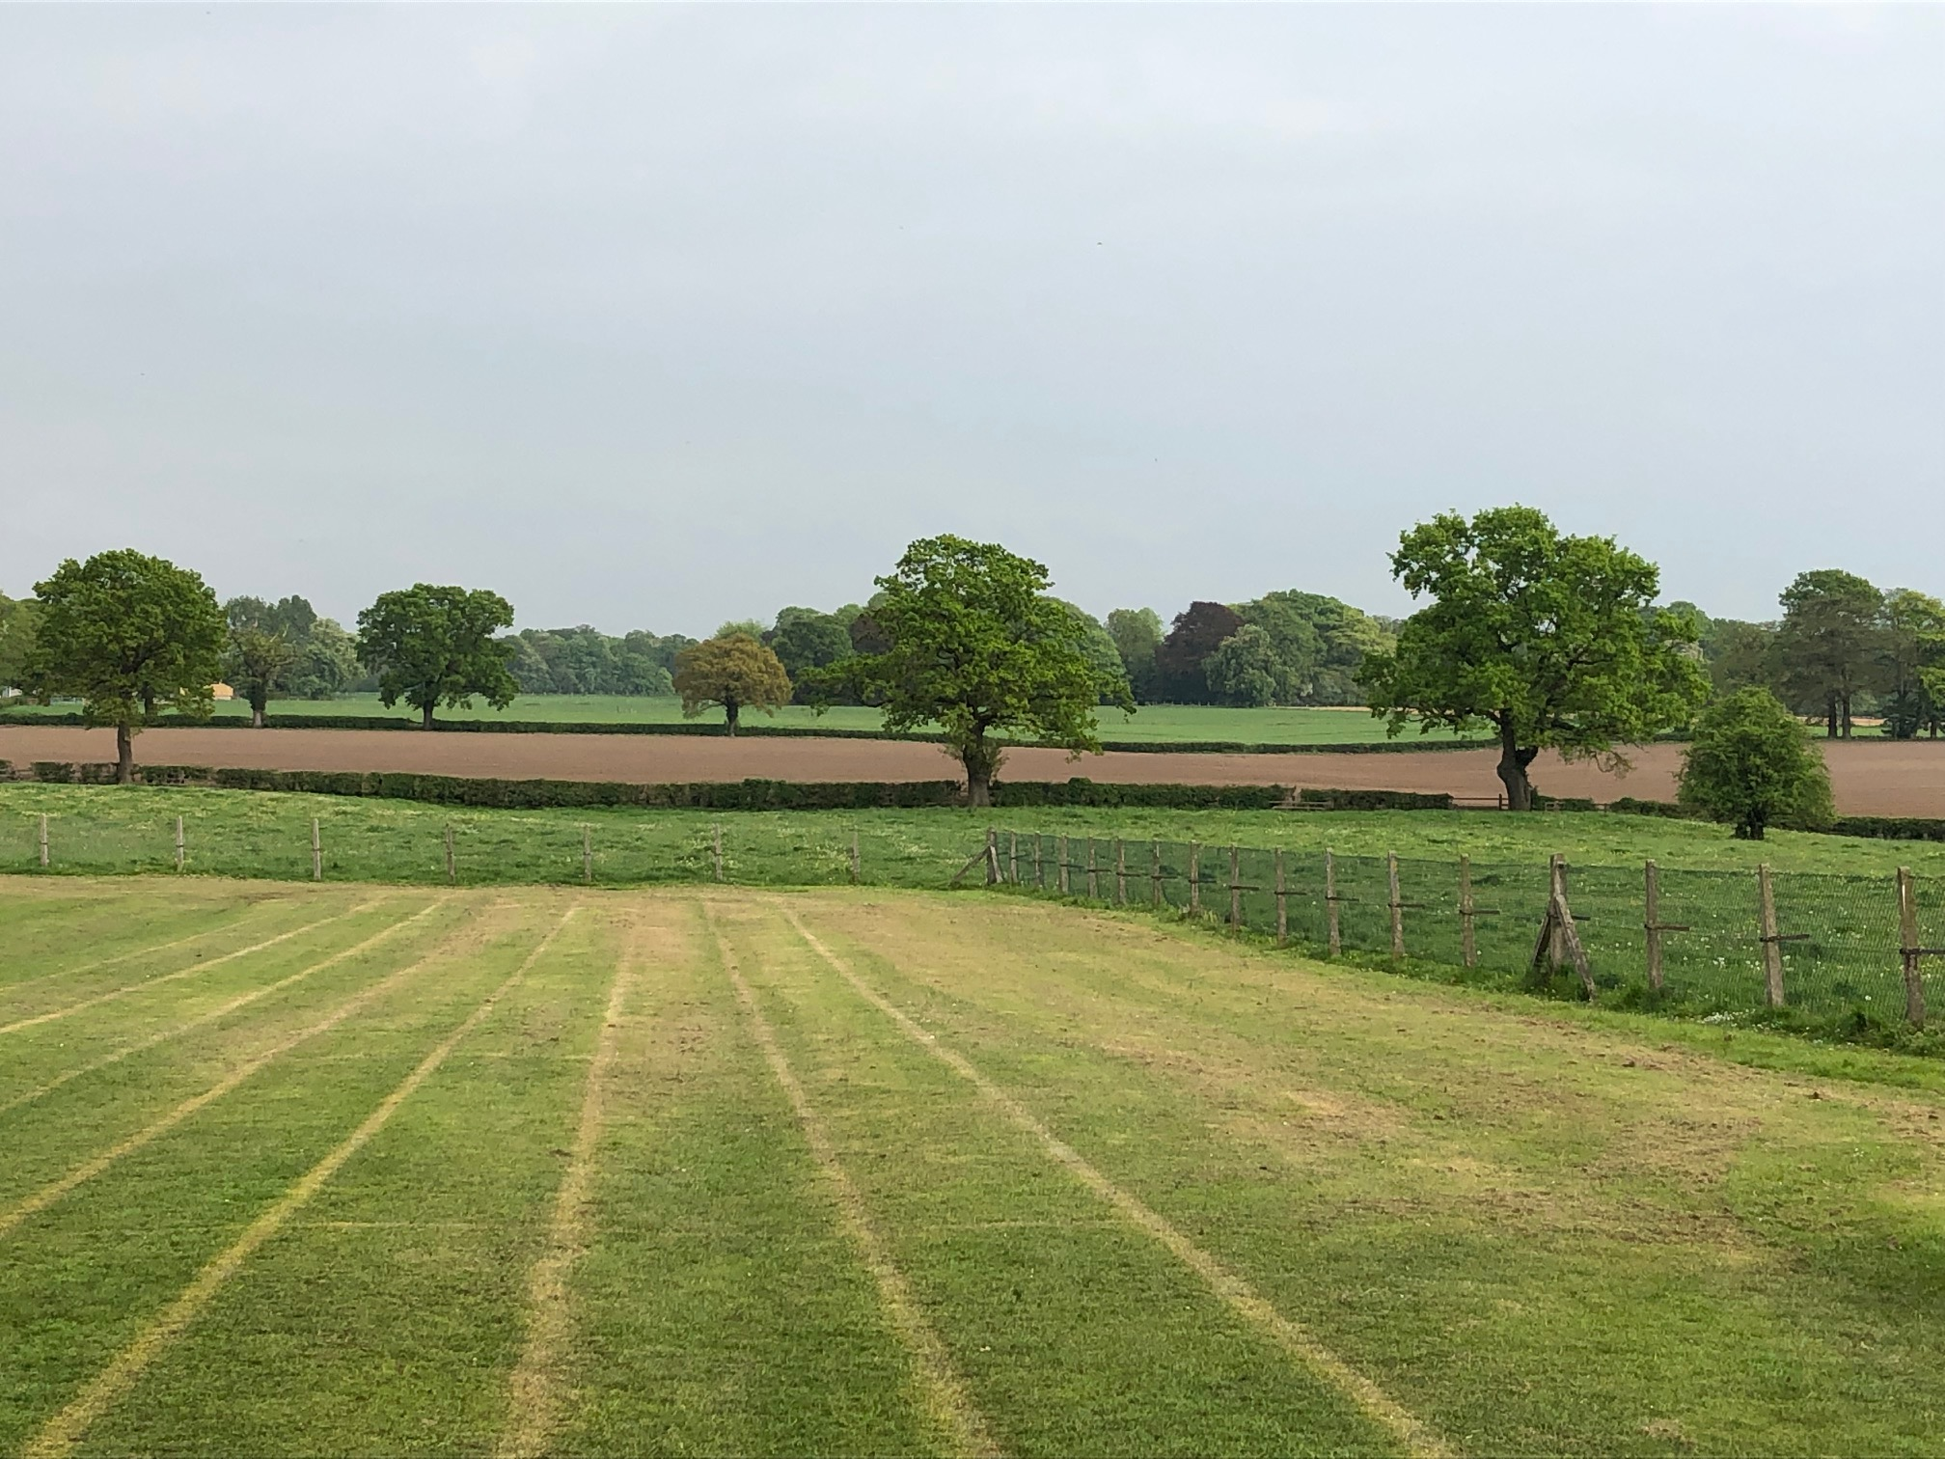

MOBBERLEY CHURCH OF ENGLAND PRIMARY SCHOOL

Church Lane, Mobberley, Cheshire, WA16 7RA

Headteacher: Mr D Stenson B.Ed NPQH

T: 01625 800 920 • E: [admin@mobberley.cheshire.sch.uk](mailto:admin@mobberley.cheshire.sch.uk) • W: www.mobberley.cheshire.sch.uk



Hello.

Welcome to MOPS, the before and after school club at Mobberley Church of England Primary School.

We have enclosed some information about both of the clubs for you. If you require a place, please complete the registration form, read and sign the before and after school agreement and return them both to Mrs. Penny Norbury at school who will then be able to book your child into the relevant clubs

Please contact Mrs. Norbury by email;  [afterschool@mobberley.cheshire.sch.uk](mailto:afterschool@mobberley.cheshire.sch.uk) or on 0770 785 2031 if you have any questions.

We look forward to hearing from you.

Kind regards,

The MOPS Team