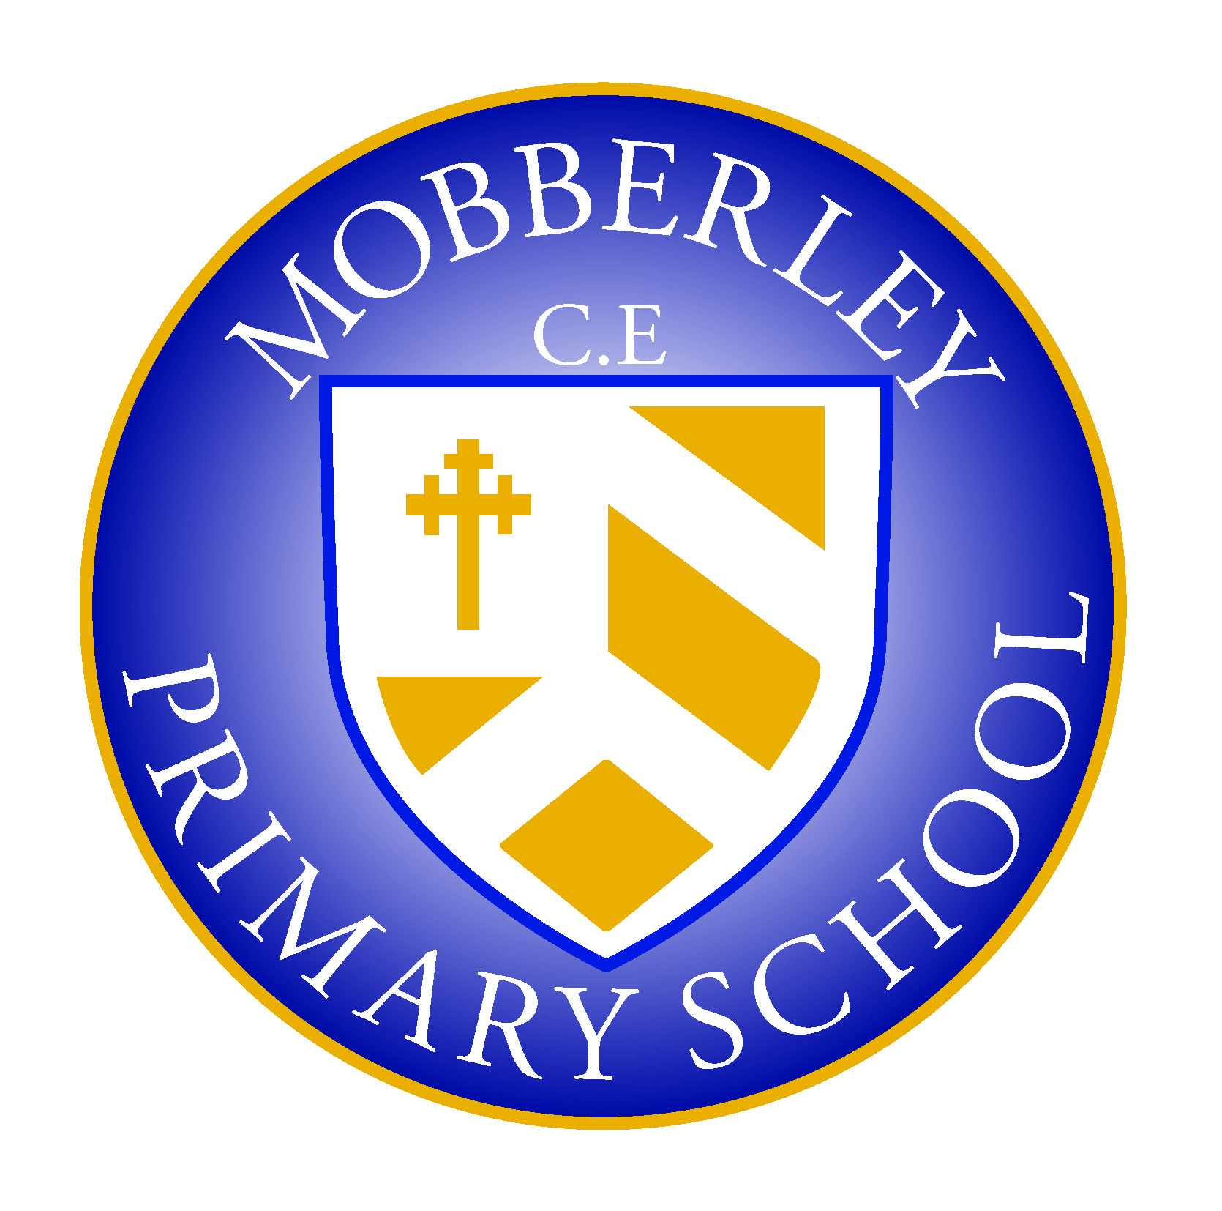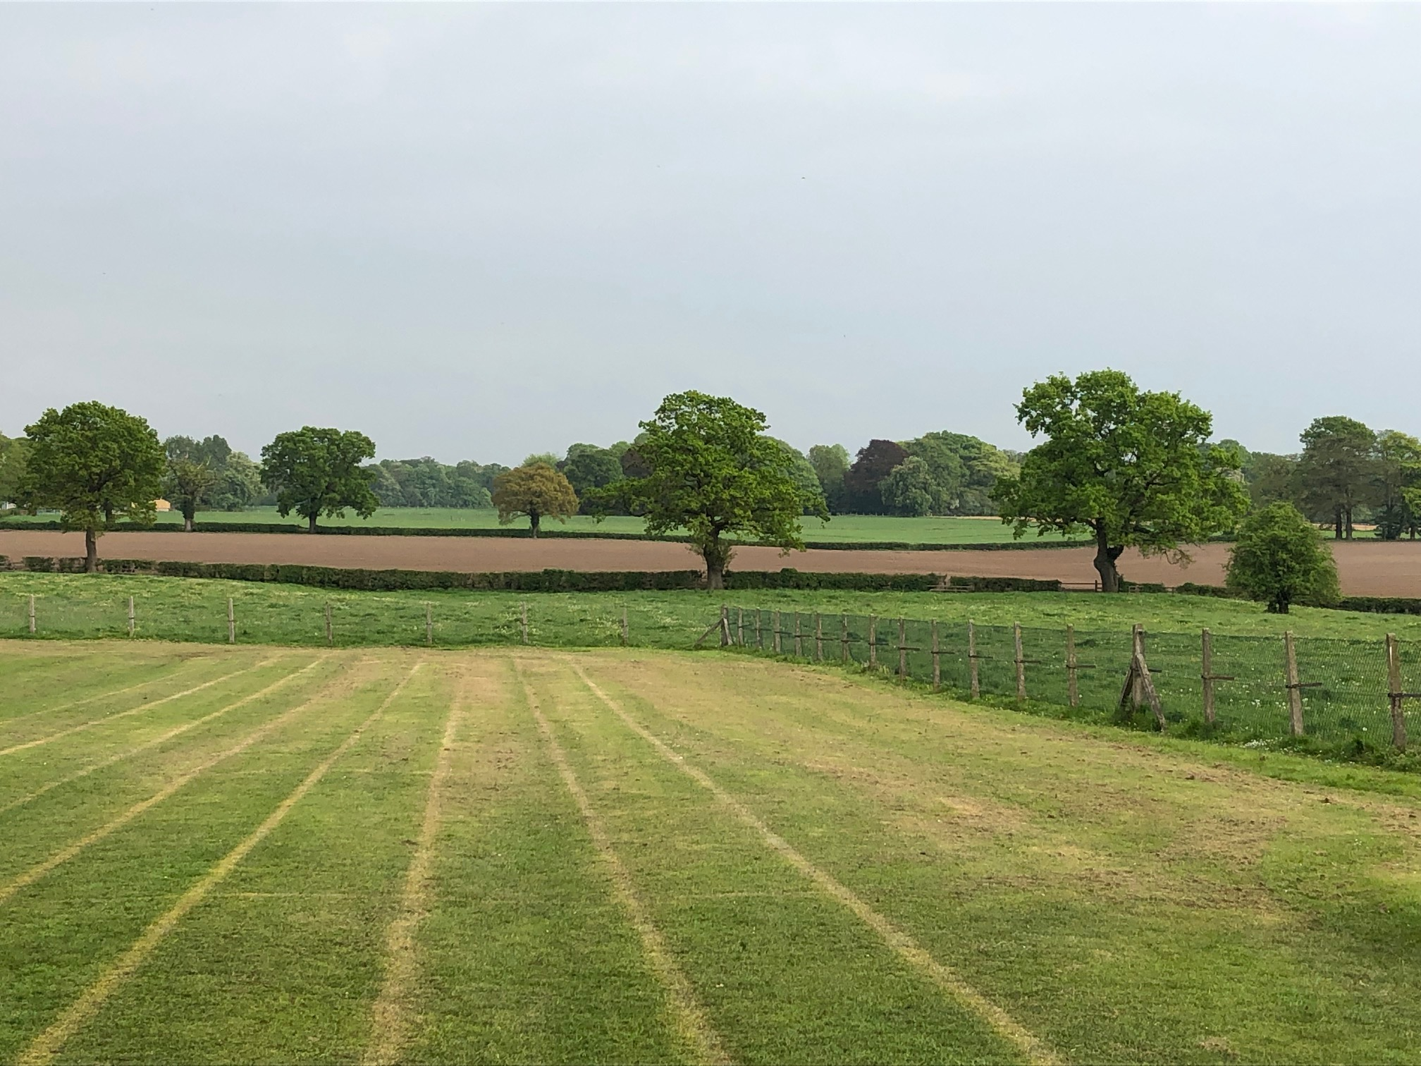

MOBBERLEY CHURCH OF ENGLAND PRIMARY SCHOOL

Church Lane, Mobberley, Cheshire, WA16 7RA

Headteacher: Mr D Stenson B.Ed NPQH

T: 01625 800 920 • E: [admin@mobberley.cheshire.sch.uk](mailto:admin@mobberley.cheshire.sch.uk) • W: www.mobberley.cheshire.sch.uk

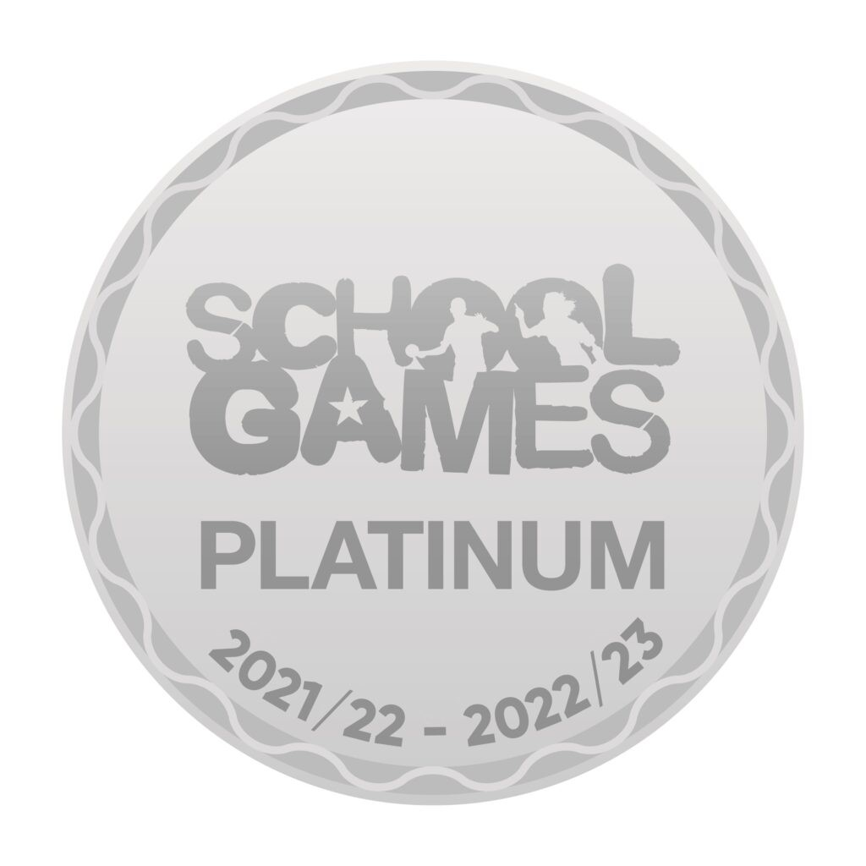

**Mobberley Before and After School Club (MOPS)**

At Mobberley C of E Primary School we are able to offer parents and carers before and after school provision for their children. The purpose of the clubs is to provide high quality childcare in a safe, secure and fun environment for all the children that attend the school. We aim to offer a wide variety of inclusive activities both indoors and outdoors and are able to use all the school’s facilities.

MOPS is located in the school's main hall and in the reception classroom, is open every day during the school term (7.30am to 9.00am and 3.20pm to 6.00pm). There are various places available at both the morning and afternoon session, which is run by a qualified staff team that have a wealth of experience and lots of ideas for fun activities. The activities include games, sport activities, art and craft, messy play, baking and den making. We have a quiet area for reading and the children have the opportunity to complete homework if they wish. There is a mix of well-planned and spontaneous activities which the children can choose to take part in with our younger children enjoying activities that complement the EYFS. ([Statutory framework for the early years foundation stage (publishing.service.gov.uk)](https://assets.publishing.service.gov.uk/government/uploads/system/uploads/attachment_data/file/974907/EYFS_framework_-_March_2021.pdf)

FAQ’S

1. How will my child get to the before and after-school club?

The children attending the breakfast club should be dropped off at the hall door where they will be greeted by a member of the breakfast club team. The children will be escorted to their individual classrooms or playground in time for lessons to begin.

The after-school staff team will collect the children from reception and year 1 classes and meet the children from the other years at our meeting point which is located in the middle of school or they will be escorted to the reception classroom. The class teachers are provided with up-to-date registers, so they know who is attending on any given night. Mrs. Penny Norbury is also a Teaching assistant with the reception class and will therefore will be the key person for the younger children that attend reception class. Please do not hesitate to speak to her about your child or if you require any more information.

If your child is attending a school run activity after school such as athletics, netball or WFA football, they can still attend the before and after-school club. We can arrange for the sports coaches and staff to bring your child to the club.

1. Do I need to provide drinks and snacks for my child and are there any other items to bring?

Breakfast is provided to all the children whilst at the breakfast club

with such things as fruit, cereals and toast with juice, milk or water available to drink.

At the after-school club, they are provided with a snack and drink. A selection of snacks will be made available such as toast, bagels with cheese, brioche and sandwiches. Fresh fruit is all ways available with a choice of juice or water to drink. Children are welcome to eat their own snacks, but we would ask that they are nut free.

**Please inform us of any allergies or medical conditions.**

Please ensure that your child brings appropriate clothing for indoor and outdoor activities. This should include sun cream and a sun hat during warmer days or warm clothing when the weather is more variable.

1. When is the club open?

The club is open from 7.30 am to 8.55am and 3.15pm to 6.00pm, Monday to Friday, during term time only. You can pick up your child anytime between 3.20pm and 6.00pm, however we do ask that you collect promptly by 5.55pm to allow time for handover with the staff team. You will be asked to sign your child out. Please note that we can only let your child go home with persons named on your registration form. If your child is going home with someone else, please inform the clubs.

1. How do I book my child into the club?

If you are interested in a place at the clubs, you will be asked to fill in an application form. Your details will be entered onto our system along with the sessions that you require. All sessions are allocated on a first come, first served basis. If we are unable to accommodate your requests, we will try to offer you alternative arrangements. Ad-hoc places are sometimes available at short notice.

All bookings and enquiries must be made directly through the club and not through the school office, our contact details are:

Phone 0770 785 2031 or email [afterschool@mobberley.cheshire.sch.uk](mailto:afterschool@mobberley.cheshire.sch.uk)

1. How do I pay for my childcare?

Invoices are emailed to parents/carers monthly in advance. We would appreciate payment by the **15th of the month** that you have been invoiced for. You can pay for your childcare in a variety of ways including vouchers, cash, BACS and tax-free childcare.

1. What happens if I need to cancel any sessions?

We try to offer a fully flexible service as we appreciate that arrangements can change.

**You are able to cancel sessions, you must provide us with 48 hours' notice to cancel without charge, if however, you do not provide enough notice of a cancellation, we will charge you the full price.** Sometimes, depending on availability, we are able to swap a session to another day for you, please ask.

**We would ask that if your child is not attending the club due to other arrangements or is absent from school due to sickness that you contact the club directly and inform them of the absence.**

7. What is the cost of after-school club?

We currently £9.50 for breakfast club with a reduced rate of £8.50 for siblings and £14.00 per session for after-school club and with a reduced rate of £12.00 per session for siblings. The cost covers everything that your child will need whilst at the clubs.

If you require any further information about Mobberley Primary Before and After-school clubs, would like to visit us or discuss the needs of your child and how we can support them, please call **0770 7582031** or email [afterschool@mobberley.cheshire.sch.uk](mailto:afterschool@mobberley.cheshire.sch.uk) and we will be happy to answer any questions. Details of our policies and procedures are available on the school website. Copies are available on request.

Ofsted · Customer service 0300 123 1231