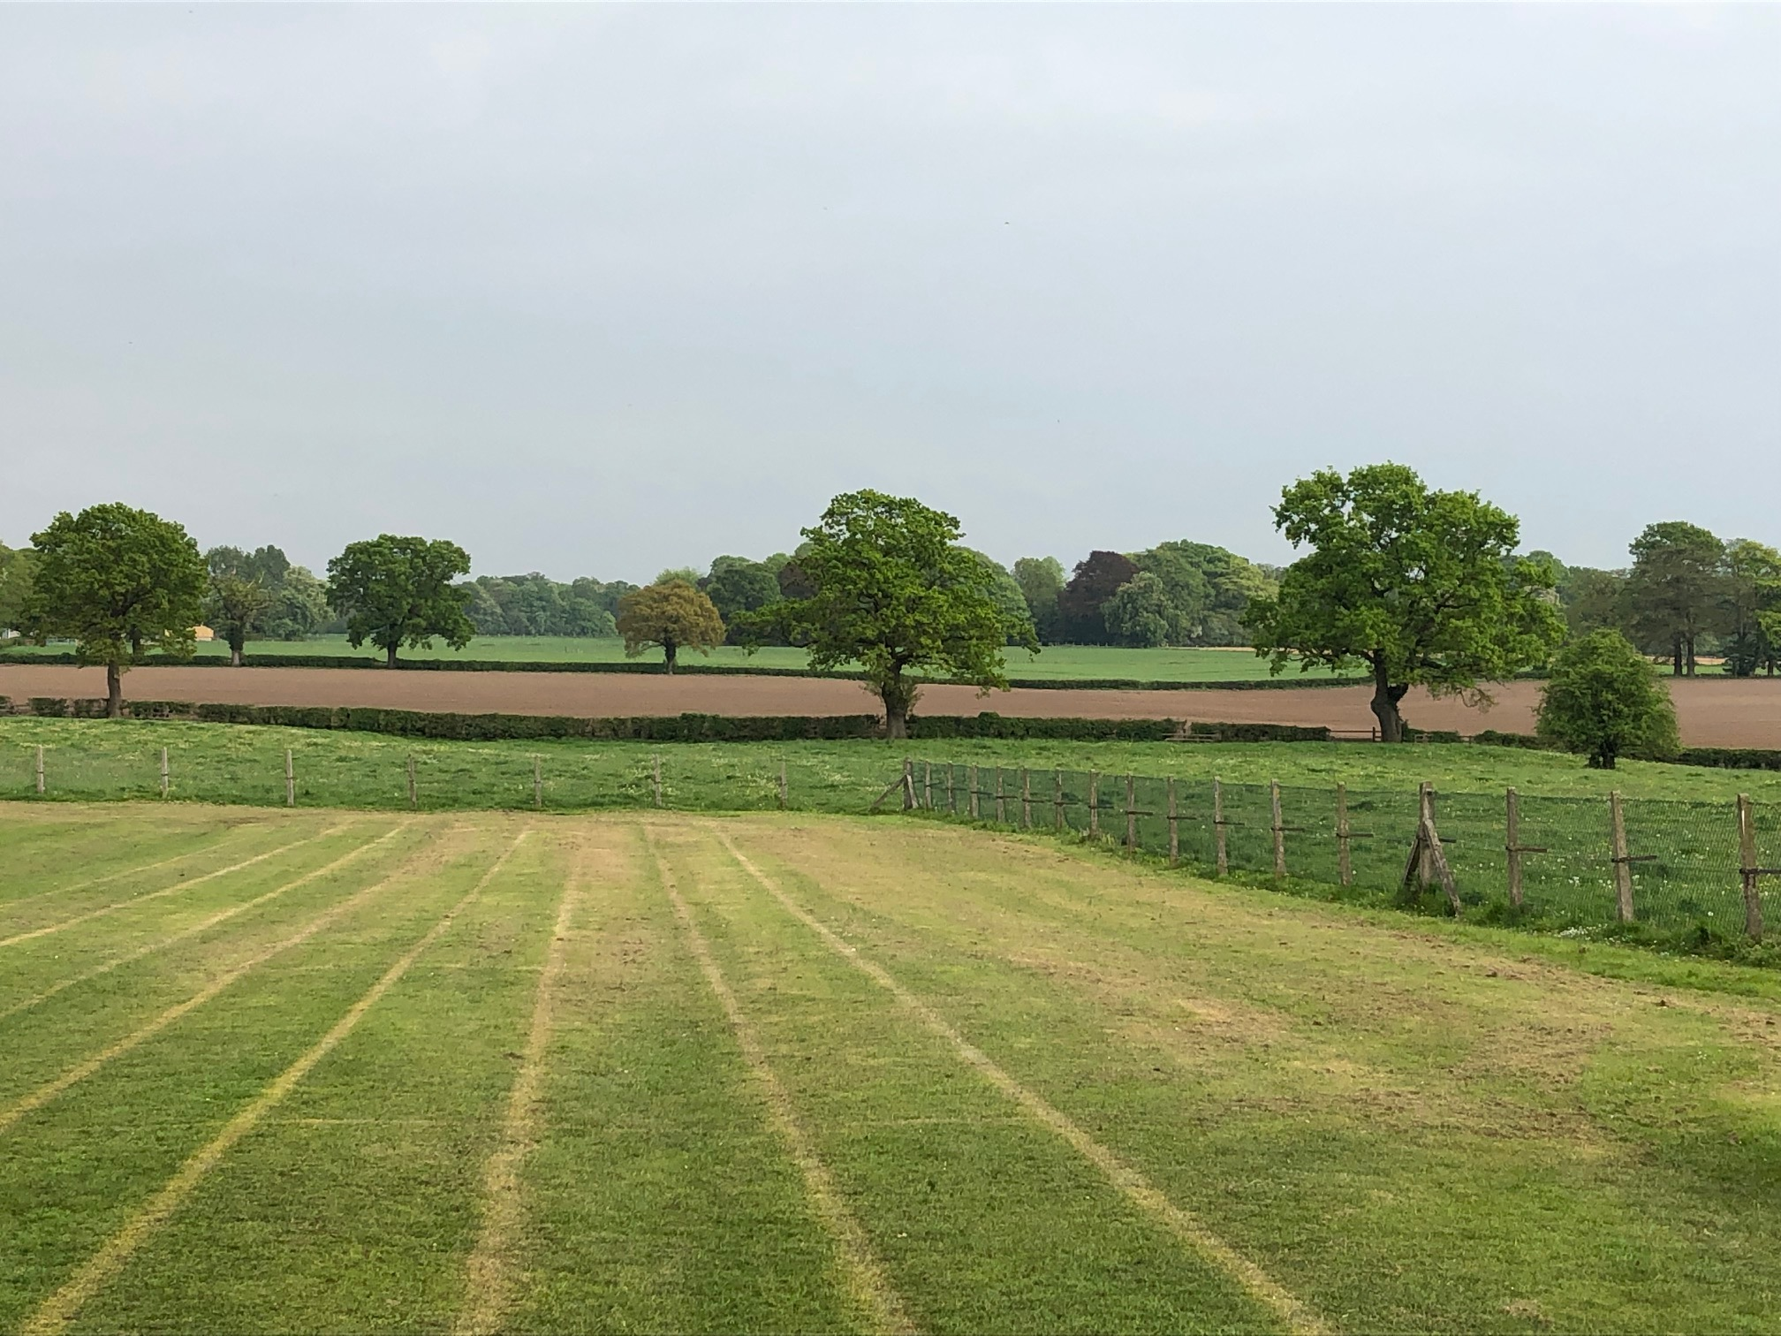

MOBBERLEY CHURCH OF ENGLAND PRIMARY SCHOOL

Church Lane, Mobberley, Cheshire, WA16 7RA

Headteacher: Mr D Stenson B.Ed NPQH

T: 01625 800 920 • E: [admin@mobberley.cheshire.sch.uk](mailto:admin@mobberley.cheshire.sch.uk) • W: www.mobberley.cheshire.sch.uk



**Mobberley C of E Primary School**

**Uncollected Child Policy 2023-25**

**Purpose**

To ensure the safeguarding of all children, it is essential that the school has a procedure in place for the safe collection of all children at the end of a school day and from our afterschool club, and guidance for parents in the event of them being late/unable to collect their child.

**Aims**

1. To keep children safe. To ensure that all members of the school community are aware of the correct procedures for the end of a child’s school day.

2. To highlight the importance of maintaining clear lines of communication and up-to-date contact details.

**Late Collection Procedure**

· The school expects children to be collected at the end of the school day, which is 3.30 p.m. at the latest or 6.00pm for Afterschool club

· If the person expected to collect the child is not there after the green infant gate is locked, the child will be kept outside the staff room (for supervision) and the parent should collect from the school office.

· If you or an identified adult has not arrived by 4pm to collect your child, the school will place the child into afterschool club with the additional cost of a full session (i.e. £14 for eldest child, £12 for each sibling.)

**Afterschool Club.**

If a child is not collected, and a parent has notified us (of an unavoidable ‘one off’ delay, e.g. stuck in traffic) staff will wait with the child for a few minutes until the collection by the designated adult.

Where a child is not collected and we have not been notified, we will follow the procedure set out below;

**Up to 10 minutes late.**

* When the parent or carer arrives, they will be reminded that they must call/email the club to notify us if they are delayed.
* The parent/carer will have a penalty charge of £10 added to their account (unless the delay is genuinely unavoidable).

**Over 10 minutes late.**

If a parent or carer is more than 10 minutes late in collecting their child, the manager will try to contact them using the contact details on file.

* If there is no response from the parent/carer, messages will be left requesting that they contact the club immediately. The manager will then try to contact the emergency contacts listed on the child’s registration form.
* While waiting to be collected, the child will be supervised by at least two members of staff.
* When the parent/carer arrives, they will be reminded that they must call/email the club to notify us if they are delayed, and that penalty fees will have to be charged.

**Over 30 minutes late**

* If no contact has been made with the child’s parents/carers after 30 minutes, the Headteacher will contact the Emergency Social Care Team for advice.
* · If you or an identified adult hasn’t arrived by 6.30pm, we will contact Children’s Social Care via the Emergency Duty Team (0300 123 5022), where a duty social worker will take responsibility for the child/ren.
* The child will remain in the care of the club’s staff/Headteacher, on the club’s premises if possible, until collected by an authorised person, or until placed into the care of the Social Care Team.
* If it is not possible for the child to remain at the club’s premises, a note will be left on the door of the hall informing the child’s parent/carer where the child has been taken (e.g. to the home of a member of staff or into the care of a safeguarding agency) and leaving a contact number. A further message will be left on a parent/carers telephone explaining events.
* · The Designated Safeguarding Lead (DSL) Mr Stenson, or in his absence, Deputy DSL (Mrs Whalley) or Mrs Bentzien, (Senior Leader) will co-ordinate the response to the uncollected child.

**Managing persistent lateness.**

The manager will record all incidents of late collection (adding late charges where necessary) and will report these to the Headteacher. The Headteacher will then speak with the parents/carers reminding them of their responsibility to collect promptly and informing the club of late collection.

· The Designated Safeguarding Lead (DSL) Mr Stenson, or in his absence, Deputy DSL (Mrs Whalley) or Mrs Bentzien, (Senior Leader) will co-ordinate the response to the uncollected child.

As a parent/carer, it is your responsibility to ensure that your child is collected on time (preferably by 5.55pm)

· Please ensure that the club has up-to-date telephone numbers to contact you in an emergency

· Please ensure we have a minimum of 4 contacts (2 main and two alternatives) to ring in an emergency

· If you are unexpectedly delayed and are unable to collect or will be late collecting your child from school, please contact the school immediately by email; [afterschool@mobberley.cheshire.sch.uk](mailto:afterschool@mobberley.cheshire.sch.uk) or phone 01625 800 920.

· If you arrange for another adult to collect your child, you must let the club know the details of that person. (As a regular or temporary arrangement)

Parents will be informed of this policy by email and it will be published on the school website

This policy will be reviewed in Sept 25 and every two years thereafter, by the Governing Body of Mobberley C of E Primary School.