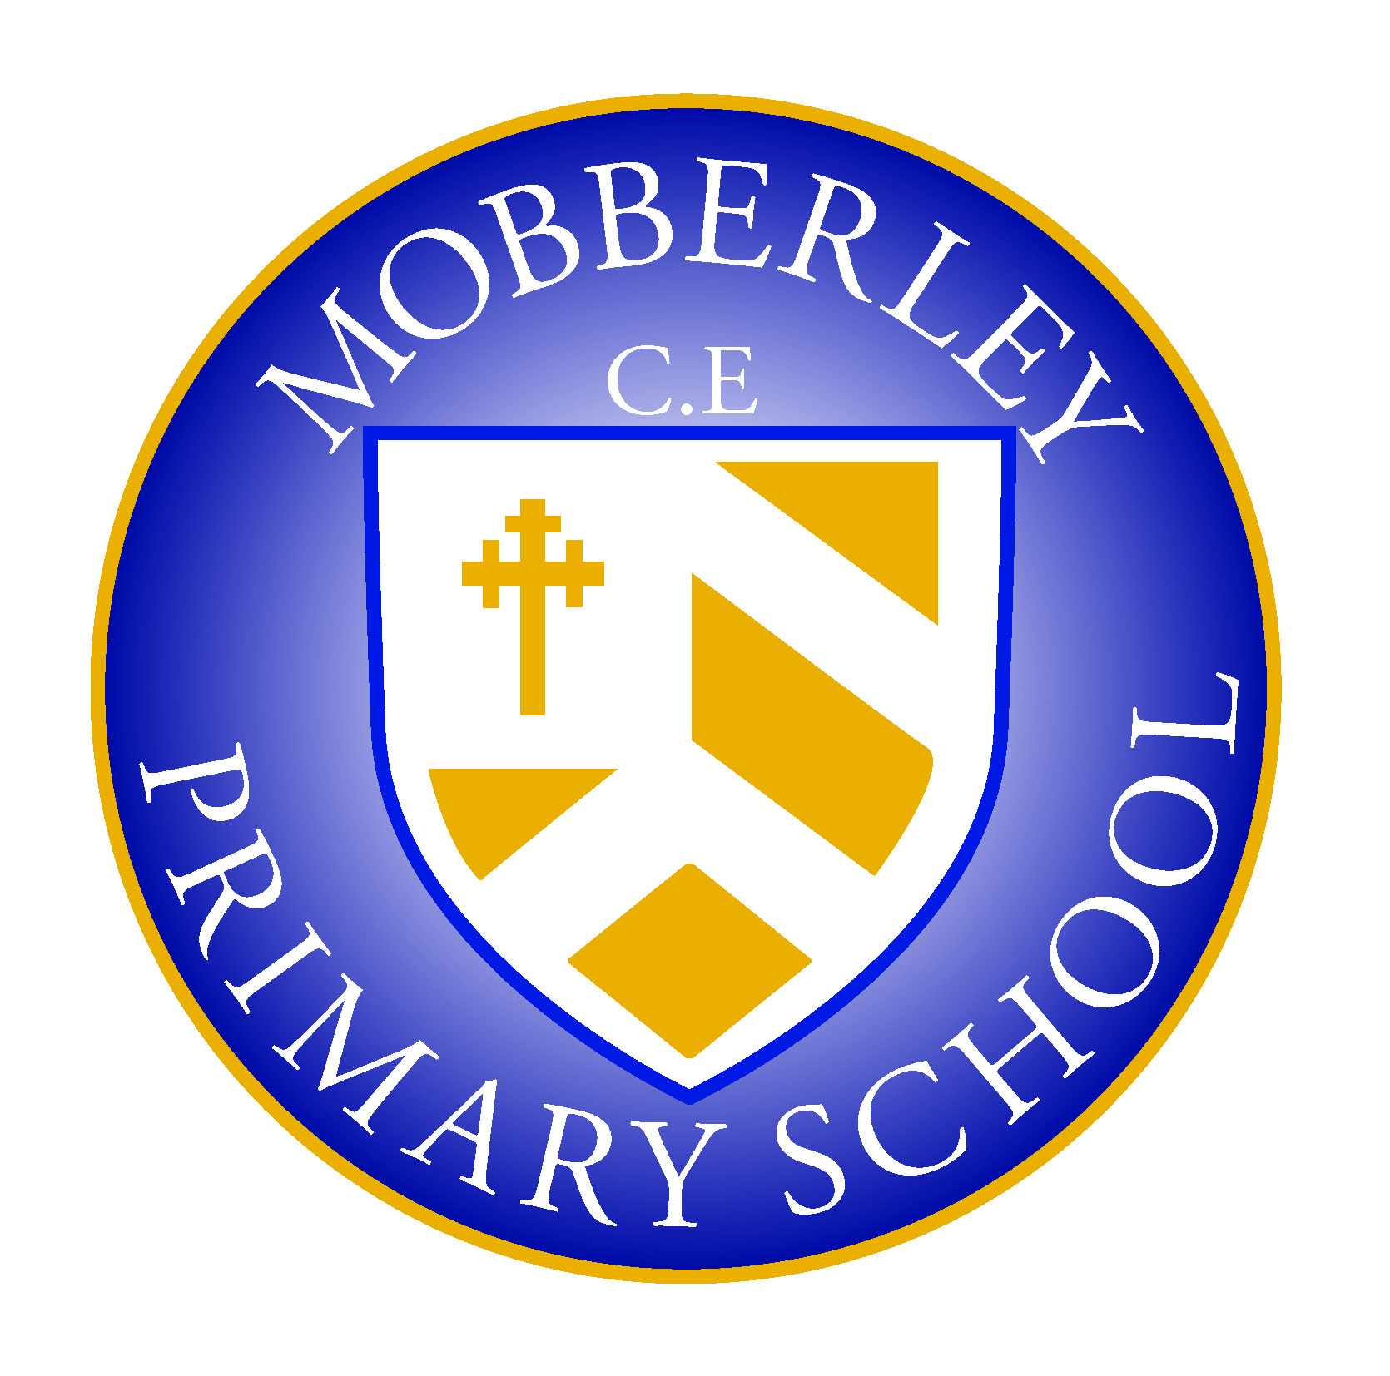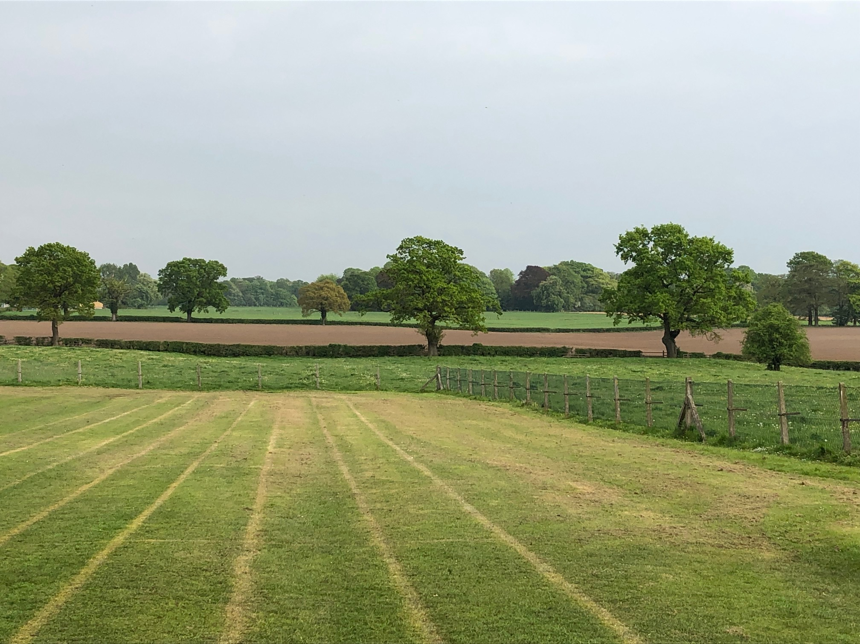

MOBBERLEY CHURCH OF ENGLAND PRIMARY SCHOOL

Church Lane, Mobberley, Cheshire, WA16 7RA

Headteacher: Mr D Stenson B.Ed NPQH

T: 01625 800 920 • E: [admin@mobberley.cheshire.sch.uk](mailto:admin@mobberley.cheshire.sch.uk) • W: www.mobberley.cheshire.sch.uk





**WELCOME TO OUR SCHOOL**

Dear Parent / Carer,

On behalf of our school community I would like to welcome you and your family to Mobberley Church of England Primary School.

Our school is a happy Christian community where each child is valued. Pupils in our school reflect the Christian values of tolerance, respect, forgiveness and understanding of all people, celebrating similarities and differences as taught by Jesus.

We expect the children to enjoy their school life and feel safe and secure within the school family. We create an atmosphere, which encourages the growth of confidence, self-discipline and the development of independent learners. We expect high standards of behaviour and work. We trust that as parents you will share our expectations and give us your full support.

Partnership with parents is essential in order that we can achieve the best for your child and we look forward to a happy and successful relationship over the coming years. We hope you will extend your knowledge of the school through contact and discussion with myself and members of staff, and take advantage of the opportunities to share in your child’s education and life of the school.

We have an active Parent Teacher Association (PTA) known as Friends of Mobberley (FOM) and you all become members when your child starts school.

I hope you will find this prospectus useful and informative. If you have a query or concern about any aspect of your child’s development, please remember we are here to help.

Yours sincerely,

Damien Stenson

Headteacher