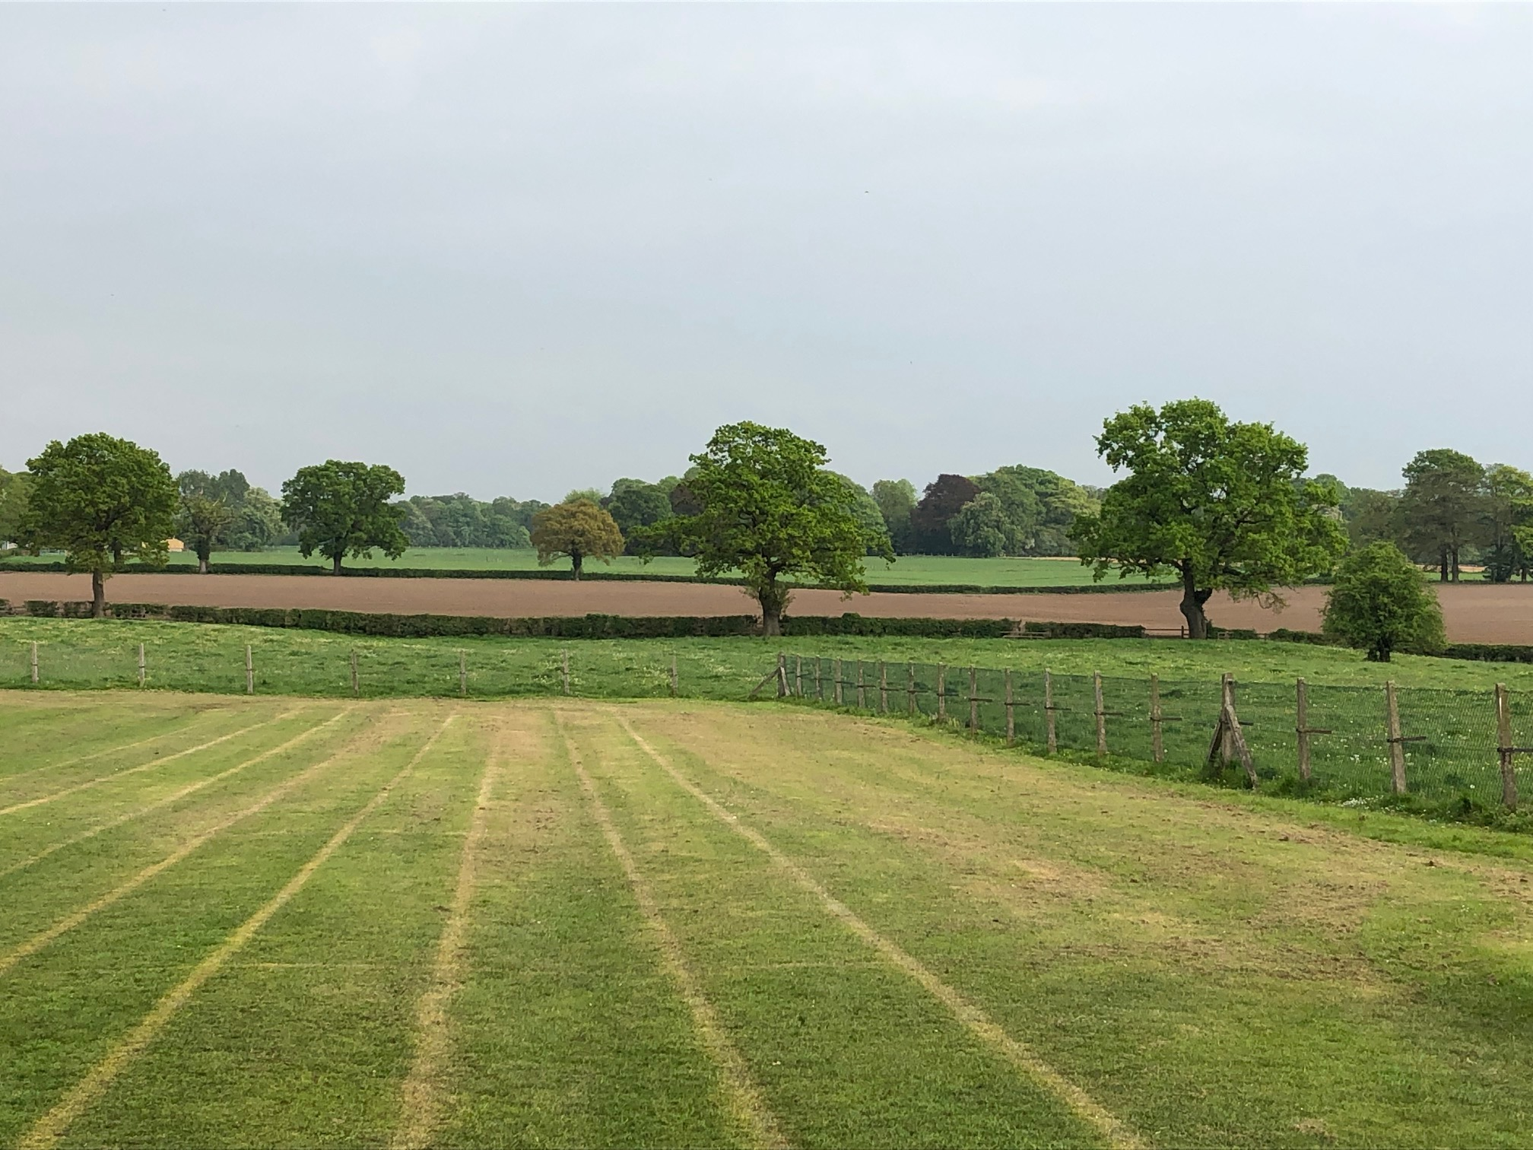

MOBBERLEY CHURCH OF ENGLAND PRIMARY SCHOOL

Church Lane, Mobberley, Cheshire, WA16 7RA

Headteacher: Mr D Stenson B.Ed NPQH

T: 01625 800 920 • E: [admin@mobberley.cheshire.sch.uk](mailto:admin@mobberley.cheshire.sch.uk) • W: www.mobberley.cheshire.sch.uk





October 2024

**Re: Term Dates, Attendance & Leave of Absence Requests**

Dear Parent / Carer,

Please find attached our term time dates for the next school year 2025/2026.

You will know that the school is bound by strict guidelines from Cheshire East around holidays and/or leave of absence during term time.

The law clearly states:

‘As parents / carers you have a legal duty to ensure that your children attend school on a regular basis. The Education Act 1996 makes it a criminal offence for a parent / carer to “fail to secure their child’s regular attendance at the school”. Amendments to the 2006 Regulations removed any reference to family holidays, extended leave and the statutory threshold of 10 school days. **Head Teachers may not grant any leave of absence (holiday) during term time unless there are specific, exceptional circumstances** e.g. to attend a close family member’s funeral**.** The amendments give **parents / carers no entitlement** to take their child out of school for a holiday in term time, even if they have a previously good attendance record. The Head Teacher and Governing Body must follow the Cheshire East guidance document and the additional guidance of the Educational Welfare Officer. Individual Headteachers and Governing boards can determine what exceptional circumstances are. Decisions will be made considering each request individually and with sensitivity to the issues involved.’

I must receive a written request for any formal leave of absence, clearly stating what the exceptional circumstances are. On receipt of the request you will be sent a response in writing indicating whether I am able to authorise the leave of absence or not.

If parents / carers, contrary to what the school has said, still decide to take their child out of school for a leave of absence then the absence will have to be coded as **unauthorised.** This may lead to further action by the local authority and a fixed penalty may be issued.

This letter reflects accurately the current legislation we are bound by as a school to enforce. We do have a duty to make you aware of this.

If your child is unable to attend school (e.g. due to illness) please email or call the school ([admin@mobberley.cheshire.sch.uk](mailto:admin@mobberley.cheshire.sch.uk) / 01625 800 920) before 9:00am. You can leave a message on our answerphone if the line is engaged or if it is not answered immediately by a member of staff. When your child returns to school you should send in a note / email explaining their absence which can be added to the register. Any child arriving at school after 9:30am is classed as absent for the whole morning session. Registers are taken by Class Teachers at 9:00am for the morning session and 1:00pm for the afternoon session. Requests for any medical appointments should be supported by a copy of the appointment letter.

The Cheshire East Attendance Office is in regular contact with school and checks registers, reconciling all paperwork relating to absences.

Through your continued support, attendance and punctuality has been an ‘outstanding’ feature of the school for many years.

If you have any questions relating to the content of this letter, please do not hesitate to speak to me in person.

Yours sincerely,

Damien Stenson  
Headteacher