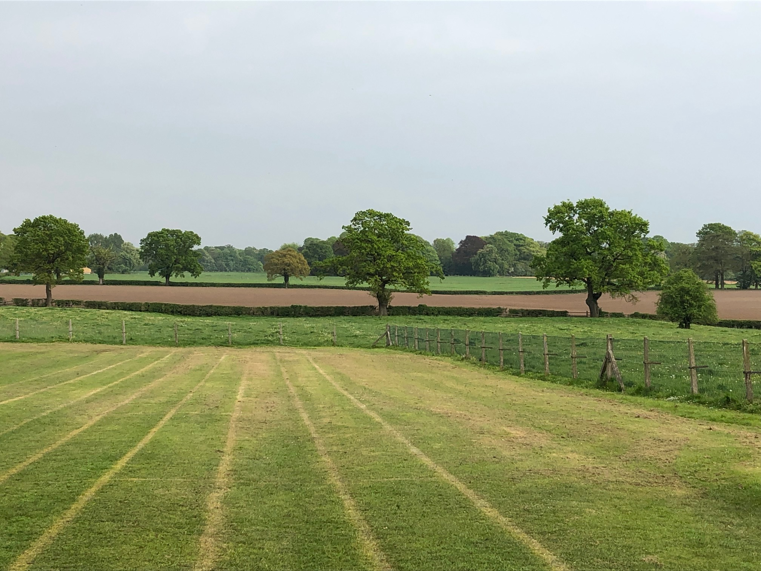

MOBBERLEY CHURCH OF ENGLAND PRIMARY SCHOOL

Church Lane, Mobberley, Cheshire, WA16 7RA

Headteacher: Mr D Stenson B.Ed NPQH

T: 01625 800 920 • E: [admin@mobberley.cheshire.sch.uk](mailto:admin@mobberley.cheshire.sch.uk) • W: www.mobberley.cheshire.sch.uk





**SCHOOL HOLIDAY CALENDAR – 2025/2026 ACADEMIC YEAR**

|  |  |  |
| --- | --- | --- |
|  | **CLOSING DATE** | **RE-OPENING DATE** |
| Summer 2025 | Tuesday 22nd July | Tuesday 2nd September |
| Autumn Half Term 2025 | Friday 24th October | Monday 3rd November |
| Christmas 2025 | Thursday 18th December | Tuesday 6th January 2026 |
| Spring Half Term 2026 | Friday 13th February | Monday 23rd February |
| Easter Holiday 2026 | Friday 27th March | Monday 13th April |
| May Day 2026 | Friday 1st May | Tuesday 5th May |
| Summer Half Term 2026 | Friday 22nd May | Monday 1st June |
| Summer 2026 | Thursday 16th July |  |

**INSET DAYS FOR STAFF TRAINING**

* Monday 1st September 2025
* Friday 19th December 2025
* Monday 5th January 2026
* Friday 17th July 2026
* Monday 20th July 2026

Note: Inset Days are non pupil days and so children do **NOT** attend school.