

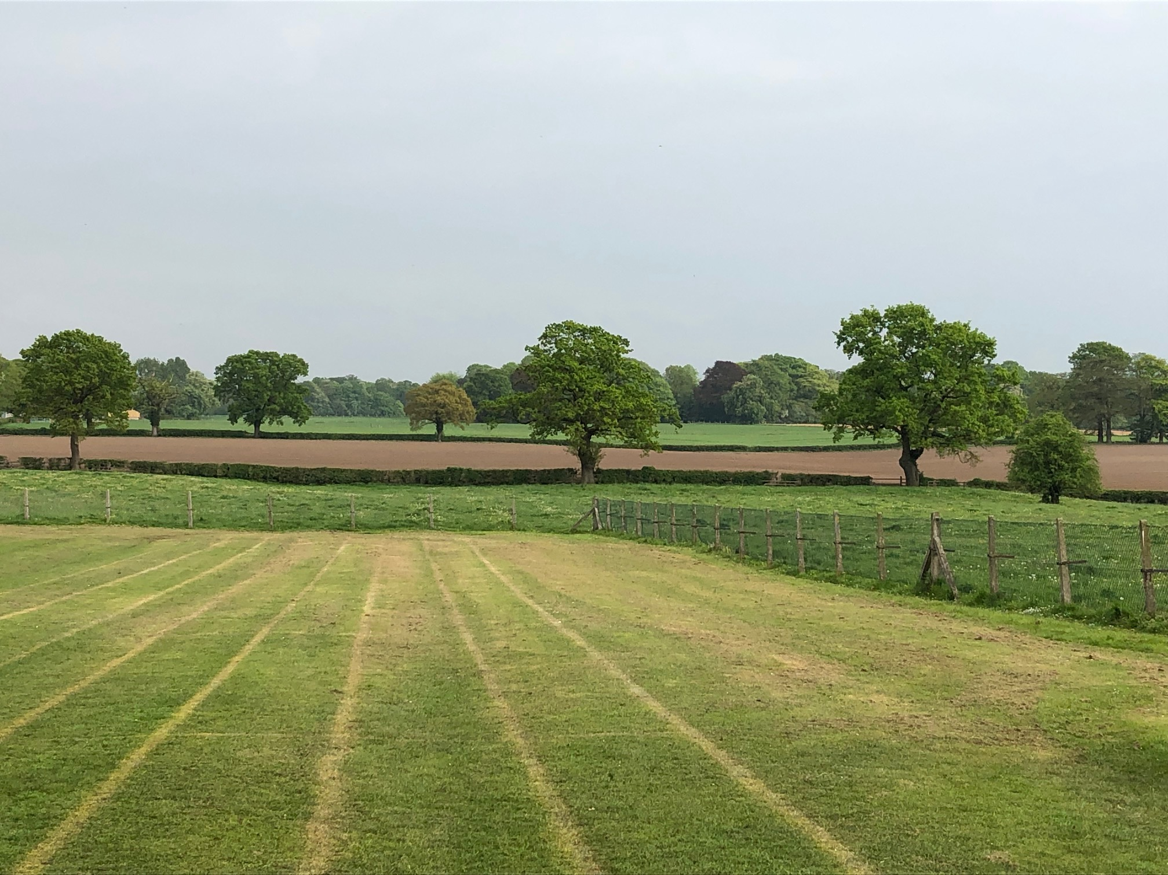




MOBBERLEY CHURCH OF ENGLAND PRIMARY SCHOOL
Church Lane, Mobberley, Cheshire, WA16 7RA
Headteacher: Mr D Stenson B.Ed NPQH
T: 01625 800 920 • E: admin@mobberley.cheshire.sch.uk • W: www.mobberley.cheshire.sch.uk

“Ask and it will be given to you; seek and you will find; knock, and the door will be opened to you”
Matthew 7:7

Lower KS2 Teaching Vacancy – Maternity cover

(1 Year Temporary Contract)

School: | Mobberley C of E Primary School
Headteacher: | Mr Damien Stenson
Address: | Church Lane, Mobberley, WA16 7RA
Telephone Number: | 01625 800 920
School Email Address: | admin@mobberley.cheshire.sch.uk
School Website: | http://www.mobberley.cheshire.sch.uk
Position Advertised: | Lower KS2 Teacher  Full Time - 5 Days Per Week, starting Sept 26. One year maternity cover position.  Experienced teachers may apply.
Salary: | MPS
Closing Date: | Monday 27th April 2026 (12 Noon)
Shortlisting:  Interviews:  Applications to be obtained from: | Monday 27th April 2026 (PM)  Thursday 30th April 2026 (AM)  School website / admin@mobberley.cheshire.sch.uk
Applications to be returned to: | head@mobberley.cheshire.sch.uk (deadline)
Mobberley C of E Primary School is a vibrant and progressive learning community. Our caring village school is a place where a love of learning is fostered, friendships are valued and achievements are celebrated.

The Head Teacher and Governors are seeking to appoint a committed, enthusiastic and creative teacher to join our team in lower KS2. The position would be for one year (Starting Sept 26.) Applications are welcomed from experienced teachers – ECTs would not be suitable for this position. The successful candidate will be a strong KS2 classroom practitioner with a focus on improving pupil outcomes. It is essential that they are sensitive to the needs and abilities of our pupils while ensuring that each pupil is appropriately challenged to achieve their potential. We are looking for someone knowledgeable and passionate about Primary Teaching with a personal drive to enable high quality classroom experiences and strong outcomes.
In return, Mobberley School can provide friendly children, a welcoming team of strong professionals, a stimulating working environment, supportive parents and a strong CPD offer.
Mobberley C of E Primary School is committed to the safeguarding and welfare of children within our care. Suitable candidates will be subject to stringent enhanced checks as part of the selection process.
Application packs (including Person Specification) can be obtained from the school website / school office – admin@mobberley.cheshire.sch.uk and returned by
noon on Monday 27th April.

Tours of the school will take place on Monday 20th April and Tuesday 21st April both at 9.30am. Please contact the office, preferably via email (admin@mobberley.cheshire.sch.uk) if you would like to book a school tour.

