
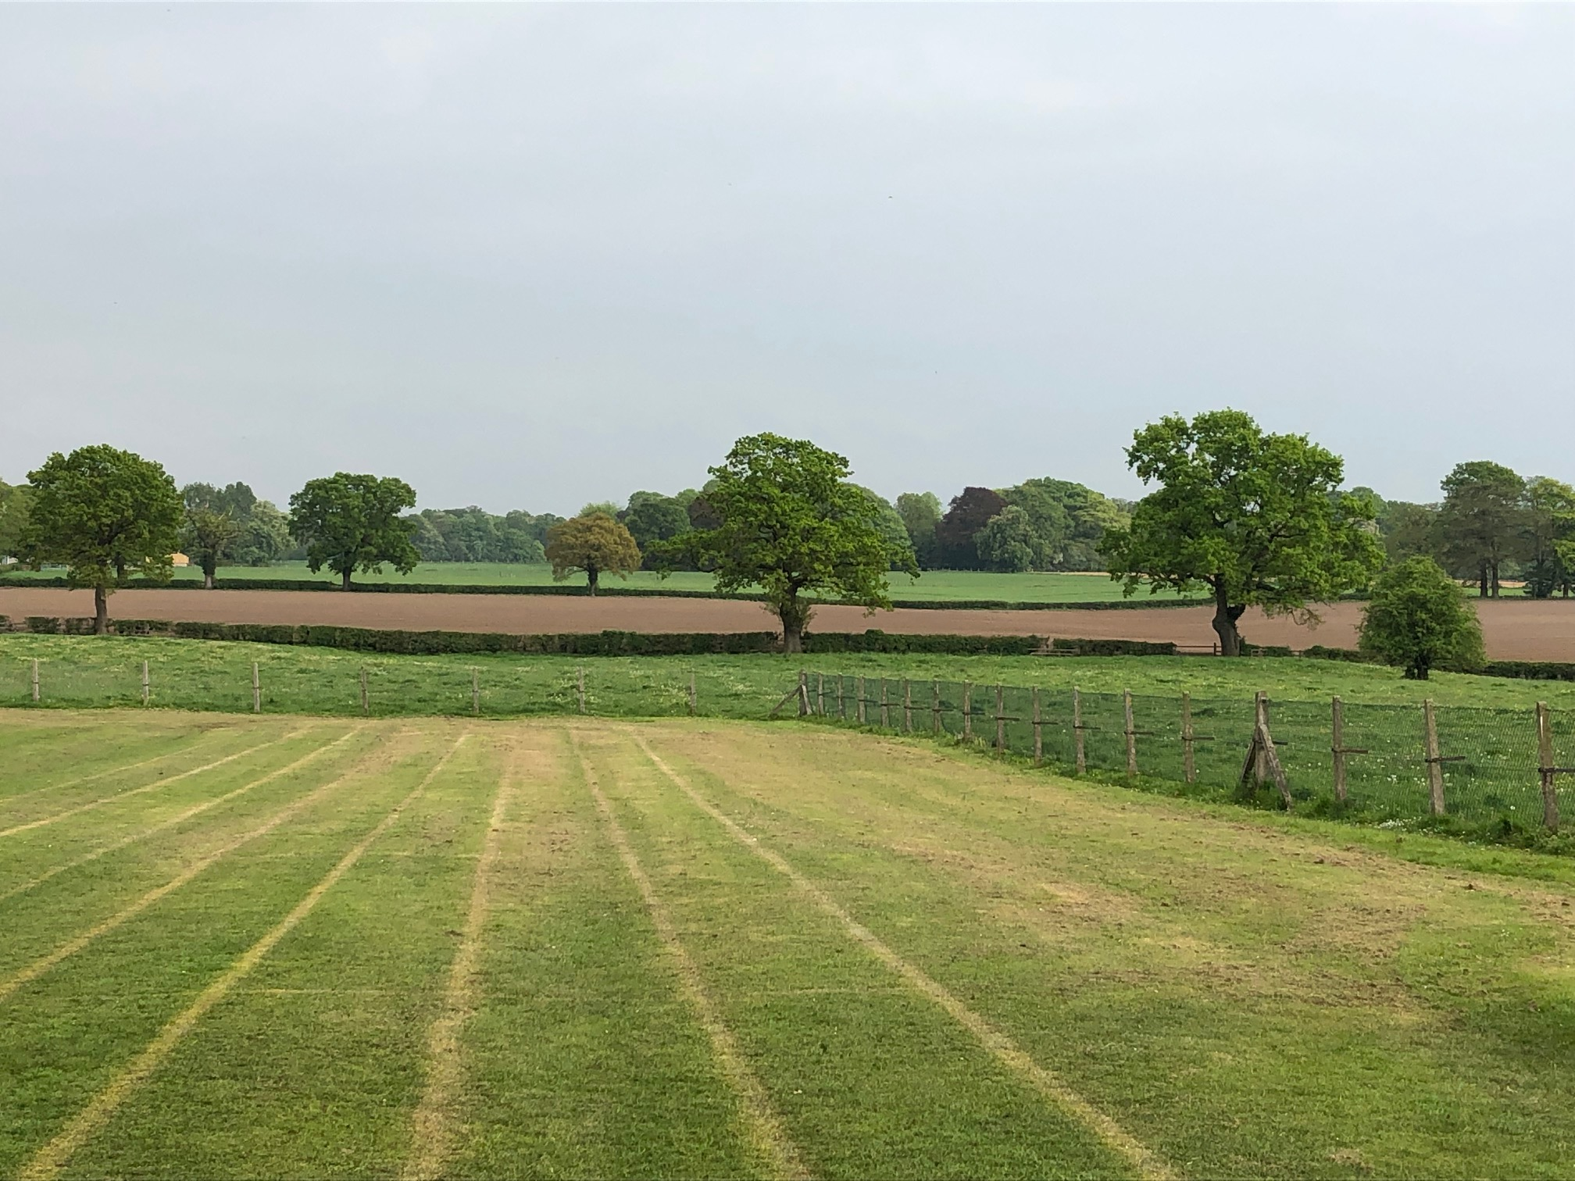
MOBBERLEY CHURCH OF ENGLAND PRIMARY SCHOOL
Church Lane, Mobberley, Cheshire, WA16 7RA
Headteacher: Mr D Stenson B.Ed NPQH
T: 01625 800 920 • E: admin@mobberley.cheshire.sch.uk • W: www.mobberley.cheshire.sch.uk





Teaching Assistant Vacancy (1:1 SEN) 25 core hours + daily Midday role

Address: Church Lane, Mobberley, WA16 7RA

Telephone Number: 01625 800 920

School email: admin@mobberley.cheshire.sch.uk

Position: Teaching Assistant (SEN) Working 1:1 to

support a child within KS1, 25 hours per week.

Position subject to a successful probationary period.

Salary: Grade 4 (£13.26 per hour)

Closing Date: Friday 25th Sept 2026

Interviews: Tuesday 29th Sept 2026

Application Pack and further information available from the school website. Completed application forms should be returned to head@mobberley.cheshire.sch.uk

At Mobberley CE Primary School, we follow safer recruitment guidelines and we are committed to safeguarding children. We expect all employees to share the same commitment. The position is subject to enhanced DBS checks and satisfactory references.

Mobberley C of E Primary School is a vibrant learning community and is proud to serve the community of Mobberley and surrounding areas. Our caring village school is a place where a love of learning is fostered, friendships are valued and achievements are celebrated.

We are looking for a highly motivated individual who can provide 1:1 support for a KS1 pupil needing support and encouragement to access learning.

The successful candidate must have good organisational skills, enjoy working as part of a team, be a clear communicator and have a passion for supporting children with additional needs. An understanding of / experience of working with Autistic children would be an advantage.
Application packs (including Person Specification) can be obtained from the school website.

Completed application forms should be returned to head@mobberley.cheshire.sch.uk by Friday 25th Sept 2026

